Function Generator Tutorial
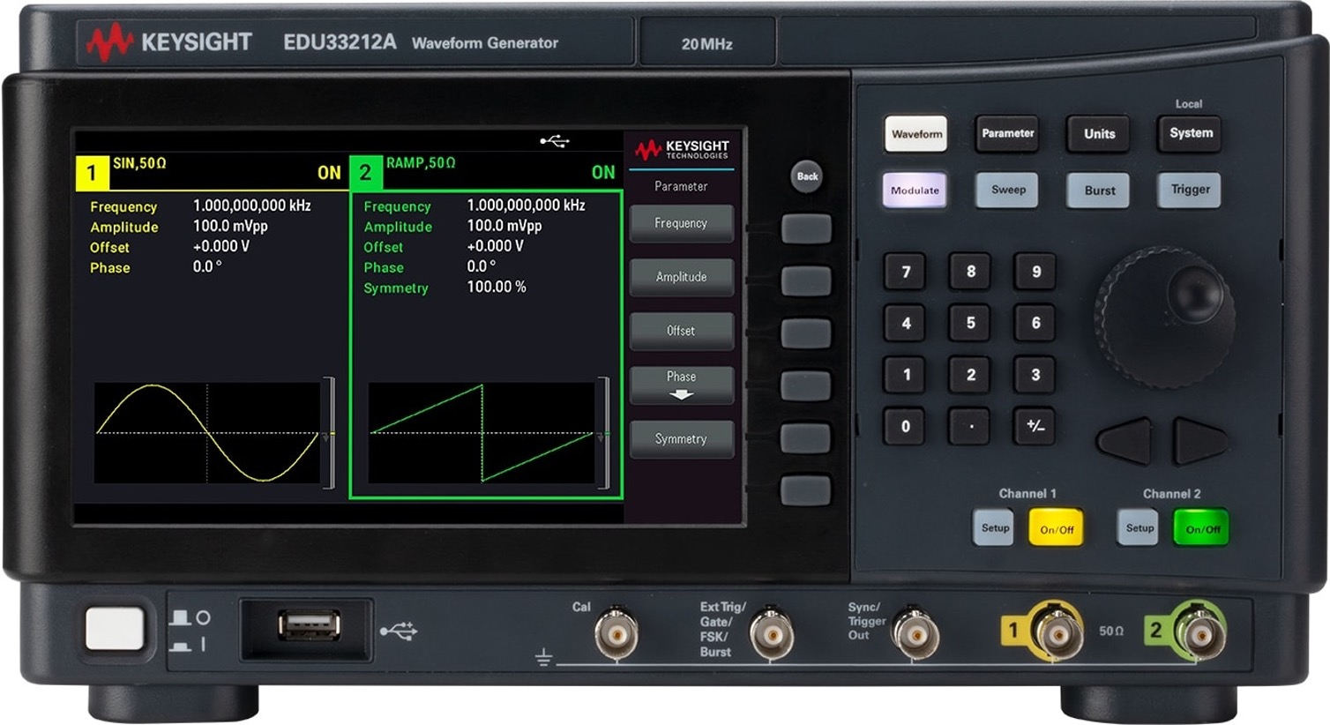
Figure 1: Keysight EDU33212A Waveform Generator (see Data Sheet).

Laboratory Outline
A function generator generates different electrical waveforms. Often, the waveform is periodic such as a square wave, triangular wave, sinusoidal wave, or sawtooth wave. DC offsets to those waveforms are an option.

Learning Objectives
- Configure the Keysight EDU33212A function generator to produce square, sinusoidal, and sawtooth waveforms.
- Validate those waveforms using an oscilloscope.

Introduction
There are many situations in which we might desire to generate a specific periodic voltage without having to build a special circuit to do so. We can do this using what is called a function generator (sometimes called a signal generator or waveform generator, although these titles often imply different specific operations).

Function Generator
A function generator is a piece of equipment that outputs an electrical voltage waveform that can vary in time, in contrast to the DC power supply that can only output a constant voltage. The output waveform of our function generator is periodic. The waveform’s shape can be chosen from a predetermined “function” list. Besides the waveform’s shape, the front panel buttons allow the user to alter other parameters of the waveform like frequency, amplitude, offset, and duty cycle.

Figure 2: The front panel of the Keysight EDU33212A function generator. At the BNC output, the center pin is the positive voltage reference while the outer shield is the negative (often the “ground” reference).
The SYNC port is used to synchronize the “clocks” of multiple devices. We will not use it in ECE110. Be careful not to accidentally confuse it with the OUTPUT port.
Figure 3: We will never use the SYNC port in ECE 110. Please do not mistake it for the OUTPUT port!
The waveform output is generated inside the device from functions stored in memory in digital form. The list of binary numbers that specify the waveform are applied to a Digital-to-Analog (D/A) converter and output as an analog waveform through the BNC connectors that are labeled as 1 and 2. The circuit symbols for several different functions are provided in Figure 4.

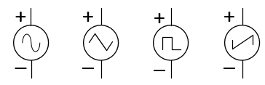
Figure 4: Circuit symbols for the sine, triangular, square, and sawtooth waveforms, respectively.
When discussing periodic signals, we often refer to parameters like amplitude and frequency and period. Amplitude is the height of the voltage (commonly in units of volts or millivolts). It might be given as the peak-to-peak height (the difference between the largest voltage the waveform takes and the smallest voltage) or, often for a signal that symmetrically takes on positive and negative voltages, the zero-to-peak voltage (half of the peak-to-peak). Period is the amount of time, often in seconds, it takes for a signal to complete one cycle and return to its starting point. Frequency is the rate at which the periods (or cycles) appear measured in cycles/second or “Hertz”. Frequency, $f_{o}$, is the inverse of the period, $T$: $f_{o}=1/T$.
Two other parameters are quite common as well. A periodic signal like a sinusoid or square wave is generated by a device like the function generator to be symmetrical around 0 volts (takes on evenly positive and negative voltage values relative to its “ground” reference). Adding a “DC-offset” to the signal can shift it upwards or downwards. Often the goal is to shift the signal upwards so that the voltage produced always falls between 0 volts and the peak-to-peak amplitude. For a square-wave signal, duty cycle is the ratio of the time in each period the signal is at its maximum value divided by the amount of time in one period. For a duty cycle of 1%, the waveform almost never leaves its minimum value and for a duty cycle of 99%, the waveform is nearly always at its maximum value. A duty cycle of 50% is what most people think of as a square wave signal. A signal in which the duty cycle is adjustable, often in response to some outside stimulus, is referred to as a pulse-width modulation (PWM) signal.
Setup the Function Generator (EDU33212A) to output a square wave with a frequency of $1000 Hz$ ($1 kHz$), a $5 V$ peak-to-peak amplitude (the display will show VPP meaning voltage peak-to-peak), and an offset of $2.5 V$. Here are the instructions:
Set the following parameters of the output by pressing the corresponding button and turning the large knob if necessary.
- Function – press the button on the function generator that shows a square wave.
- Amplitude – Press the Ampl button. This shows you the default amplitude value in the display. To quickly change the amplitude, turn the dial in the upper right corner. Alternately, fine tuning can be accomplished by pressing the up/down arrows. Either control changes the value of the digit blinking on the display. A different digit can be made to blink by using the left/right arrow keys.
- Frequency – Press the Freq button. Adjust settings with the dial or arrows.
- Offset – Press the Offset button. Adjust settings with the dial or arrows.
Validate your signal by connecting it to the oscilloscope (You can combine two BNC-to-banana cables to create a BNC-to-BNC connection, just make sure you do not allow the black and red banana plugs to touch/short). Press the Default button on the oscilloscope. Are you surprised by what you see on the oscilloscope? READ ON! …
There is one hidden problem with the function generator. We cannot treat it as an ideal voltage-signal generator. It turns out that it has a $50 Ω$ internal (Thevenin) resistance. This cannot be changed, but the designer of the function generator also recognized that the most typical “loads” the function generator would see would be either $50 Ω$ (an equipment standard) or a much larger resistance like $1 MΩ$ (another equipment standard and the default value on our oscilloscope). In their wisdom, the designer of the function generator has allowed us to tell the function generator if we are connecting a [default] 50 Ohm load or a so-called High Z (high-impedance) load. Nothing physically changes within the function generator while changing between these two modes to tell the function generator what we are attaching, however, the digital display of the function generator will adjust its digital readout to report either the instrument’s Thevenin voltage, $v(t)$, or half of that voltage, $\frac{1}{2}v(t)$. See the figure below.
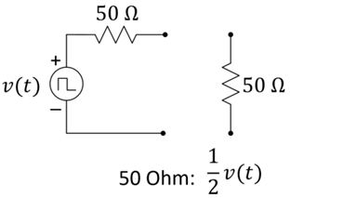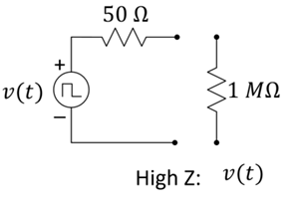
In 50-Ohm mode, the function generator will display a value only 50% of the open circuit amplitude because that is what you would see across a 50-Ohm load. In High-Z mode, the function generator will display the open-circuit voltage because that is what you would see when measuring across a high resistance.
Figure 5: If your load is 50 Ohms, use the default 50 Ohm setting of the function generator. If your load is expected to be much higher than 50 Ohms, use the High Z setting. High Z is most common in ECE 110.

Switching between 50 Ohm and High Z modes
High Z
This can serve as a bookmark for you. How to set High Z on the function generator.
If you want the displayed value of the function generator to match the voltage read by a high-resistance device, you need to set the function generator to “High Z”. Do this by selecting “Setup”, “Output Load”, “Set to High Z”. The function generator will now show the voltage value of the “ideal internal source”. You must do this each time you use the function generator because the 50 Ohm default setting will report $\frac{1}{2}v(t)$. Start the oscilloscope and place it in the default setting. Configure the function generator [default is 50 Ohms] and the oscilloscope [default is $1 MΩ$] so that they agree with each other in high Z. Connect the two devices (you can use two BNC-to-banana coaxial cables to create one BNC-to-BNC cable…just be careful not to let the red banana plugs touch the black banana plugs). Adjust the horizontal and vertical settings to get a good view of your signal.

- Sketch the signal seen on the oscilloscope on the figure below. Don’t forget units, labels, and values.
Figure 6: The output of the function generator square wave.
Return your borrowed equipment and clean up your benchtop before leaving for the day.
Thank you!

