Falstad’s Circuit Simulator

Circuit Simulators
A circuit simulator is a great way to learn about circuits, test new designs, or troubleshoot a design prototype that has failed on the breadboard. Eventually, we will teach you to use the LTspice simulator which provides better precision, better visualization tools, the ability to save circuits for later exploration, and the ability to add our own components. However, an installation is required and the learning curve is a little higher and, even for simple circuits, the added steps in running a small simulation can be intimidating. The circuit simulator at https://www.falstad.com/circuit provides a good first view of a circuit simulator that yields results in seconds!

Falstad.com/circuit tutorial
To get started, point your browser (Chrome is recommended) to https://www.falstad.com/circuit. Let’s look at a circuit that will help us explore ideas regarding series and parallel resistors. Go to Circuits BasicsResistors. Here, you will see the circuit of Figure 1. As you follow the procedures below, always remember you can Reset (or reload) the page to start over.
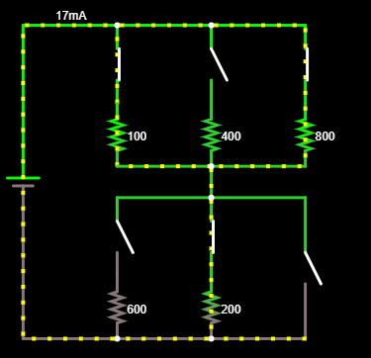
Figure 1: Falstad circuit simulator, CircuitsBasicsResistors
This circuit contains a battery, six resistors, and six switches. Let’s delete the 800 Ohm resistor.
To delete an element: Hover over it until it turns a light blue color, then use CTRL-X on your keyboard…just the two keys, “Ctrl” and the key marked “x”. Alternately, you can use your cursor with a dragged left-click to make a box around elements you want to delete and then go to EditCut (here, you will also see the keyboard shortcuts!).
Delete the switches that were above and below the just-deleted 800-Ohm resistor so that your circuit looks like the one in Figure 2.
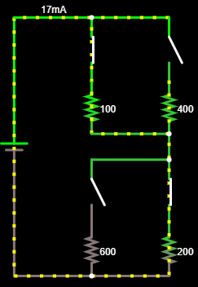
Figure 2: Falstad circuit with four resistors.
Now, change the values of all resistors to 100 Ohms.
To change a value: Hover over the element until it turns light blue. Right-click and choose Edit… In the popup window that appears, change the value and click Ok.
Change the value of the battery, in the same manner, to 9 volts, D/C, with 0 volts of offset so that it matches the 9-volt battery of the ECE 110 Electronics Kit. Remove the two leftmost switches as well. Replace them with wire.
To add wire: Type w on your keyboard and your cursor will change to a + symbol. Click and drag to draw wire.
Your diagram should now look like the one in Figure 3.
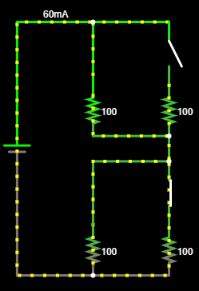
Figure 2: Falstad circuit with four resistors, two switches.
Click on the switches to alternately open and close them. Note that you can hover over a resistor or the battery to see the current through it, the voltage across it, its numerical setting, and the power dissipated or generated by it. Negative power indicates the device is delivering power to the rest of the circuit and positive power indicates the device is dissipating power, perhaps in the form of heat. Explore these questions and others you may have:
- What settings (open/closed) of the switches maximizes current through the lower-left resistor?
- What is the maximum power delivered by the battery? Under what switch conditions is it maximized?
- Is the power delivered by the battery always equal the sum of the power dissipated by the resistors?
Jot down a few of your observations regarding these questions.

Hover over the lower-left resistor, right-click and choose View in Scope. The voltage vs. time of that resistor is now plotted in the scope view at the bottom of the window. Click on the switches to see the voltage across this resistor changes as the switch settings are changed.
Here are a few other shortcuts to know while using Falstad.com/circuit:
To drag elements: Press the space bar to be able to click elements and drag them.
To draw resistors: Press r to draw resistors.
Undo: Use CTRL-Z to undo your last action.
Play around and find your own short cuts to add to this list! You will find questions similar to this exercise in the homework, but, more importantly, you should find this to be a quick and valuable tool to experiment on your own!
- Build your own simple circuit using a voltage source plus resistors, capacitors, LEDs and/or switches. Demonstrate keyboard shortcuts. (You may be asked to upload a video where you build this circuit and run the resulting simulation.)

