Technical Report Writing in Engineering…Focus on the ECE 110 Car

Prerequisites
- Completed ECE laboratory experiments.

Learning Objectives
- Write a technical report suitable for an engineering course.

Procedure
This 75-point (low-stakes!) midterm report prelab exercise to give you some experience to think about structure, tying multiple labs together based on their underlying theme, and doing teamwork with individual and team-wide expectations.
This 75-point (low-stakes!) midterm report prelab exercise to give you some experience to think about structure, tying multiple labs together based on their underlying theme, and doing teamwork with individual and team-wide expectations. Each member of your team is expected to contribute in a non-trivial way to this midterm report. To do so, your team should subcontract the responsibility of one separate section of the body of the paper to each teammate and plan a meeting ahead of the deadline to work as a team to complete the abstract, introduction, and conclusion while ensuring that the paper reads through smoothly as if written by a single individual. Each section should be augmented with the netID of the teammate who is ultimately responsible for its creation and content. The topics and division of labor will be provided later in this document.
Teams should leverage work already completed as much as possible but be willing to re-create an experiment or generate new supporting data if they recognize gaps or errors. This midterm report is a short exercise to prepare students for the final report which will carry a heavier weight. Treat it according with respect to the time invested.

The Art of Technical Report Writing

Start with a Review
Begin with a review of your semester’s work regarding the car. This review should help you find relevant materials to build a story around what you have accomplished and to fill in gaps where needed. Some aspects of the semester are listed here:
- Circuit schematics and breadboards; Mapping a schematic to a breadboard
- Multimeters and oscilloscopes; taking measurements accurately
- Simulation
- Kirchhoff’s Laws, Ohm’s Law; Voltage divider
- RC time constants
- Getting around power limits (and slowing a car wheel with series resistance)
- Motor-drive circuits using nMOS transistors
- Oscillators and Pulse-Width Modulation (PWM)
- Photoresistors with light-seeking and light-avoiding robots
- nMOS-based logical AND operations for differential and common wheel-speed control
- Storytelling and pitfalls of assumptions and biases.
Be prepared to dig deeper on concepts you don’t fully understand by revisiting course materials, office hours, your lab TAs, recommended texts, or online resources. These review/background materials can be greatly helpful in producing a strong report.
Your audience is your instructor, your TAs, and your fellow students who know about as much about electronics as you do!

Consider the Audience
Your audience is your instructor, your TAs, and your fellow students who know about as much about electronics as you do! This report should be technical, but careful not to assume too much. Make any mathematical solutions clear in method much as you would have done to earn full credit in GradeScope homework. Use the engineering tools (M2k, schematics, simulation, etc.) and skills as expected in a technical report. This will affect your score on many of the rubric items. Keep this in mind throughout.

Report Format
Midterm Report Title (Team)
Abstract (Team)
Body of paper…
Introduction (Team)
Section 1 Photoresistor (netID#1, with team input)
Include theory, data, figures, calculations, references as appropriate
Section 2 Voltage-Divider (netID#2, with team input)
Include theory, data, figures, calculations, references as appropriate
Section 3 Schmitt Trigger (netID#3, with team input)
Include theory, data, figures, calculations, references as appropriate
Section 4 Motor Drive Control (netID#4, with team input)
Include theory, data, figures, calculations, references as appropriate
Conclusions (and Future Directions, Team)

Title
Yours will be a midterm report. Your report will investigate the methods used in creating various versions of a working car. You get to choose the title and focus of the paper. Think about what you were most intrigued with as you built the various versions of your car. What skills and tools got you there? Like any author, you may wish to adjust it as the details of your paper take form.
Midterm-Report: My Midterm Report Title Here

Abstract
The goal in technical writing is to generate a report that
- conveys your experiments and results at a level appropriate for the intended audience,
- follows a structure consistent with other sources of technical reports of similar nature and purpose,
- highlights key findings that are anticipated to be valuable to others.
Technical report writing has both similarities and differences to the Art of Storytelling which we used for developing our oral report. Build excitement around your selected key aspect of the car. Why should others want to read your report? What will the report give them that they didn’t have before? Yours should leverage tools like the oscilloscope or multimeter, circuit schematics, block diagrams, data in tables or plots, equations and derivations.
The abstract may contain similarities to Freytag’s pyramid. In the abstract below, the exposition, inciting incident, and rising action is replaced by a “pain point” followed by a description that elevates the severity of the problem and stoking interest in a solution. The solution to the problem is then proposed and the abstract ends happily. In the abstract, the main ideas are presented, but the details are best left to the body of the paper.
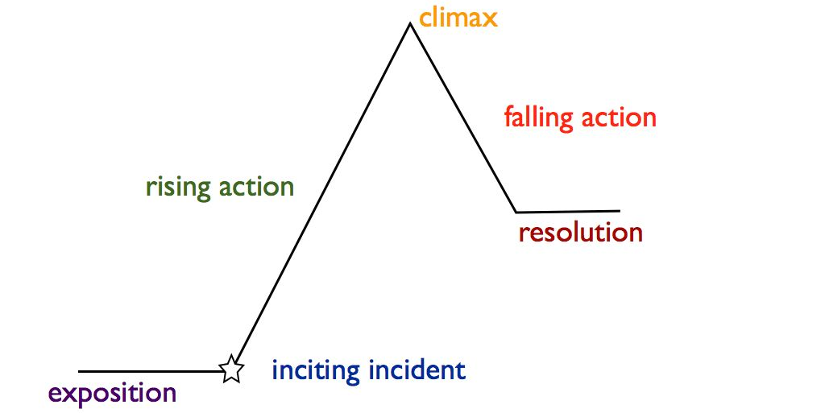
The abstract may contain similarities to Freytag’s pyramid.
Abstract: Instructors often identify significant weaknesses in the ability of a team of undergraduate students in engineering to generate a written report. Too often, the student team relies on distribution of responsibilities between teammates to accumulate disjoint pieces of information, often with incomplete sentences, poor formatting, and random pieces of data. The broader message of the document is lost to the reader and overarching conclusions are missing entirely. It is our finding that students will perform much better on written technical reports after considering the purpose of all portions of the report. Students in ECE 110 produce better reports after being properly trained.
You can write your abstract first but there is no firm and fast rule. Take careful consideration of what you learned throughout the semester. Think about what the highlight of the car has been (for you) and think about how you may want to motivate others to learn about it. It is important to draw the interest of the reader in quickly using a limited number of words. This is the purpose of the abstract. Keep it short, but let the casual observer know if they will find information of interest in the document that they may feel compelled to read further.

Introduction
This is where you will explore the problem and other solutions explored prior. Often it includes a number of references indicating that the background and state-of-the-art in solutions is well-known and that the proposed solution follows a natural progression. Many of your references for this midterm report may come from the lab procedures and other materials made available to you, but others may come from, say, your own research online.

Body
The body of the paper will often consist of several sections, each outlining one aspect of your solution. The presentation should be clear and written with appropriate attention to the intended audience. Outcomes supporting your claims will be presented. The body will be the bulk of your report and we’ll assist you in this document to determine what you may want to include.
Before writing the body or introduction, first produce an outline of what your team wants to emphasize. Glance through the rubric again, then determine as a team a direction for the report. Decide which schematics, data/plots/table, equations/derivations, and discussions are important to each section of the paper.
Individual: For this report, we want you to focus the report on light-seeking and light-avoiding robotics. In this case, a division of labor could be assigned where one teammate focuses on the photo-resistor datasheet and characterization, while another teammate focuses on voltage dividers and the expansion of the voltage-divider rule to the photo-resistor, while another teammate focuses on the behavior of the Schmitt trigger with its high-input resistance, and the final teammate discusses the motor-drive and connections that make the control fully functional. Not all sections will take the same amount of effort or time. When a teammate finishes their individual section, they need to transition into an assistant role to aid teammates who need additional help. The team is ultimately responsible for the overall success of their project.
…for the recommended division of activities among teammates.
Optional: If your team would like to construct a report worthy of extra credit, you could consider additional sections focused on speed-control, straight-run, or the logical AND operation. You may want to compare power efficiency of wheel speed control based on current-limiting resistors (the Falstad simulation) to power efficiency of speed control based on PWM signals with an nMOS motor drive.
Team: While each teammate would take responsibility of a portion of the paper (approximately one page plus-or-minus per teammate), the entire team ensures the completion of the project and the report including editing, abstract, conclusions, and continuity such that it flows as from one voice. There is no minimum length to the paper, but it should not exceed 8 pages.

Conclusions (and Future Directions)
Having presented the research, this is an opportunity to provide an “executive summary,” pulling the main points from each section while providing a concise argument for how they support your claims. Many readers might find your abstract interesting enough to jump to the conclusions of your paper. Here, they hope to find further support that your work will enhance their own knowledge and skillset and decide if a careful reading of the paper is in order. Rest assured that your TA will read the entire paper. Include future directions if you feel more work could have been done to support the current report or if you see interesting avenues for new projects related to the work already finished. Future directions are not needed in your midterm report but could add to its value.
Look at each section of your paper and determine what it contributes to the work. How does each portion assist in understanding the overall robotics solution? Provide a quick summary that ties the ideas together in one or more general conclusions without going back into the details already presented in the body of the paper. It should not be a duplication of the abstract but references to specific sections of your report’s body to validate the strength of the study.

Avoid Plagiarism
The penalty for plagiarism is high. All courses will issue a 0 on the assignment, but you can also expect a reduction in your letter grade or an automatic failure. No one wants this embarrassment!
Unfortunately, plagiarism cases occasionally appear and are dealt with severely. Here is some of what you should know.
- It is never okay to use code or language in your report from another source without documenting the source. Nor is it allowed to start with someone else’s documentation and make editing changes in an attempt to “make it your own.” It is not your own despite your paraphrasing and that is still plagiarism.
- ECE 110 allows the use of properly-documented resources (code and language) from outside resources, but only with proper reference and a clear distinction between the work you have personally accomplished and that which was done by a third party. Any report that blurs the distinction between what the team has accomplished and what the team has “borrowed” is plagiarism.
- Use of documentation from another student of ECE 110 (past or present) is not acceptable. We have a database of old reports and students who do this will be caught and charged through the university’s FAIR system.
- Some courses outside of ECE 110 do not allow any code from outside sources whether you document it or not. Always ask if you are unsure of the course’s policy.
You do not want this embarrassment, the associated penalties, nor this blemish on your record. The report is your personal responsibility even with teamwork. Ask questions of them and make sure your teammates don’t “cut corners.”

Other Thoughts
When generating a report, it is not uncommon for the author to recognize holes in their understanding or in their data. Sometimes an additional experiment or two can be conducted to help. Perhaps additional knowledge gained throughout the semester will provide deeper understanding of an earlier exercise. Don’t hesitate to find ways to improve your report.

Rubric
A rubric for grading is a set of guidelines by which the TA will critique your work. For this midterm report, the TA will be using the following rubric. Reflect on the rubric often as your report takes form.
For your final project (completed in the next few weeks), there will also be a design element added to the rubric.

Criteria | Rating Scale |  |  | weight | Score
 | 3 | 2 | 1
Formatting | Report has correct structure, complete sentences, tables, figures, captions, labels as appropriate. | Report has some structure, but some details are lacking. | Structure is very poor. Minimal effort in appearance and form. | $×5$= | /15
Communication of Concepts | The paper communicates the goals, methods, and solutions well. Report makes significant use of course topics with explicit analysis. Circuit schematics, plots, and tables provide important details to the reader and are properly labeled. | Report provides calculations without significant relevance to the goals of the paper or makes errors in theory or calculations. Visuals are poorly labeled or explained; provide little benefit to the reader. | Only numbers and text are present without evidence that the concepts are understood. Schematics or other visuals are weak or missing entirely. | $×5$= | /15
Tools | The oscilloscope (M2k) and other data was used to gain insight into the operation of the circuit. One or more plots support the information relayed in the report. | An oscilloscope plot or data from the multimeter was included but provides minimal support to the goals of the report. | Little relevant data was included from the measurement devices. | $×5$= | /15
Teamwork | There is strong evidence of equal contribution and responsibility from the teammates expressed in the paper. Furthermore, the paper has been edited to provide a consistent voice throughout the sections. | Multiple or all team members show contributions, but document does not reflect improved quality from that collaboration; sections are disjointed. | Collaboration between teammates appears weak and/or individual contributions are not clear. | $×5$= | /15
Conclusions (and Future Directions) | Conclusions are stated and supported by the body of the paper. Future directions (if included) consider any shortcomings or an interesting expansion of the current work. | Conclusions are presented but not well supported by the paper. | Missing or vague. | $×5$= | /15
Total: |  |  |  |  | /75

