HCD: Examining Assumptions (Cont’d)

In Lab Team Exercise:
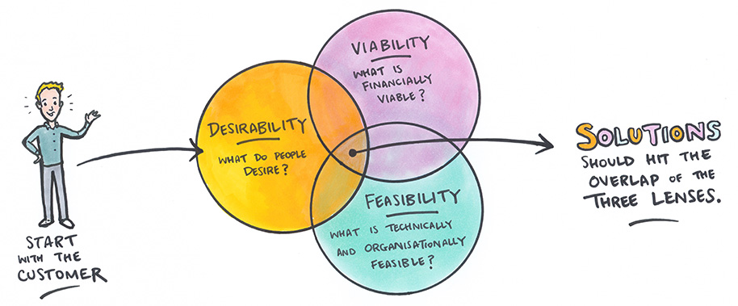
Here, again, is that graphic on Human-Centered Design:
Recall that all three of these circles are integral parts of effective solutions and that time spent early in the project to understand desirability will offer the most benefit. You do not want to waste precious resources engineering a solution that fails to satisfy the needs and desires of everyone involved (the stakeholders).
Part 4 (with your team):
Have each group member share out their assumptions from the first question of the prelab exercise. Reflect for a moment with the team - are there any assumptions that were shared by the members? Why do you think that might be? Are there any assumptions from the team members that were unexpected to you?
Important! All questions are repeated on the last page so that you can print and submit a smaller document to GradeScope.

- Have a team member serve as scribe to write out the thoughts shared during this discussion.
The discussion you just had with your team is not unlike the documentation and acknowledgement of assumptions that any design team might undergo at the beginning of a project.
- Based on this conversation, why do you think it’s so important for this process to be conducted as a team?
When designing any product or experience, it’s often extremely important for design researchers to conduct interviews with potential users. Interviews typically involve a series of open-ended, non-leading questions about an interviewee’s experiences. Interviews are rarely conducted solo; it’s imperative that at least two team members are present.
- Based on what we’ve learned about assumptions and design, why do you think it’s so important that multiple team members are present at each interview?
In advance of these interviews, researchers will prepare a list of open-ended, non-leading questions for interviewees. “Leading questions” are questions that are written or delivered in such a way that they point a person towards a particular answer. For a simple example - “What didn’t you like about the roller coaster?” points a respondent towards the negative, while “How was your experience on the roller coaster?” opens up the interviewee to respond in whatever way they’d like.
- Why do you think it’s so important that questions asked in an interview are non-leading?

- Have a team member serve as scribe to write out the thoughts shared during this discussion.
- Based on this conversation, why do you think it’s so important for this process to be conducted as a team?
- Based on what we’ve learned about assumptions and design, why do you think it’s so important that multiple team members are present at each interview?
- Why do you think it’s so important that questions asked in an interview are non-leading?

