Debugging: Hardware Practice

Learning Objectives
- Apply a procedure for efficient debugging.

Introduction
In a previous exercise you were presented with a three-tiered method to efficiently debug circuit hardware. Careful planning and layout reduce the chance of error and improve the ability to “see” the key test points of the circuit. Knowledge of the most-common issues provide an opportunity to eliminate the most probable errors first. Finally, a systematic divide-and-conquer breakdown of your circuit at certain test points (while removing and then re-attaching the downstream circuitry) can help you home in on the problematic portion(s) quickly. Use your oscilloscope extensively!
While it is good practice to work to avoid circuit failures, you should also understand that failures are key to the learning experience. Each time you pause to examine your circuit or debug an issue, you will also be taking time to think through what you know and expect. The debugging process is a natural mechanism for making learning “sticky” so that you don’t merely go through the motions of learning but retain the concepts in your mind long-term.
Build the circuit of Figure 1 and use the oscilloscope to assist in testing and debugging as you work.
Do not use a battery, use the E3631A power supply on your benchtop to supply the 9 volts to your circuit.
Remove the wheels of your car while testing or set it on a block so that it doesn’t run away from you!
Keep a journal.
The Circuit: Suppose the following circuit is intended to run the motor at full speed when a room is darkened and stop entirely when in light. The user finds that the motor runs in both a dark room and a bright room. The design also has a red LED indicator light intended to illuminate brightly when the motor turns off and turn off entirely when the motor is running.
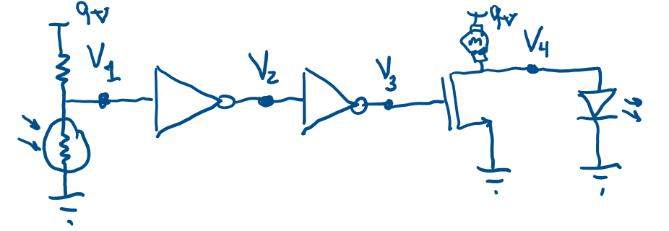
red LED
$$10 kΩ$$
Figure 1: Circuit to debug with test-point voltages labeled.
Your journal should include notes on the following:
- As you build each sub-circuit, how did you know it is functioning properly before going to the next sub-circuit? Include what you expected and what you saw?
- What did not work as planned?
- What adjustments and corrections did you need to make to get a fully functional circuit?
- What meaning do your wire colors have?
- What aspects of this debugging exercise were most helpful to you?

