Motor IV Characteristic and Thévenin Model

Laboratory Outline:
Up until this point we’ve used devices that can be treated as ideal for most practical purposes. We assume ideal voltage sources, ideal current sources, ideal resistors (perfectly Ohmic), ideal voltmeters, and ideal ammeters. Yet, non-ideal devices are what life gives us. Motors and batteries are two such devices. As engineers, we must recognize non-ideal behavior and ask pertinent questions…How fast can my motor move? How can I slow it down? How long can the battery run two car motors? How can I control the speed while maintaining a reasonable power efficiency? Replacing a device with complex behavior with a simpler model that is accurate over a certain range of uses allows an engineer to make reasonable predictions even before building and testing a prototype.
Motors convert electrical energy into kinetic energy using coils of wire and magnets. An accurate model capable of predicting behavior under a multitude of use conditions would require attention to many details and can lead to a complicated lumped-circuit model. We can, however, develop a simple linear model that approximates the motor’s behavior under a handful of DC stimuli. That is, we can generate multiple operating points and model this non-ideal device with a perfectly-linear IV curve (a Thevenin-equivalent model) that predicts its behavior quite well under this particular limited-use case.

Learning Objectives
- Measure, analyze, and model the IV characteristics of a DC motor.
- From the IV data, describe a region of linear operation through an IV equation.
- From the IV data, describe a region of linear operation through a Thevenin equivalent circuit.
Estimate the battery life while continuously driving two motors.

Motor Characterization through IV
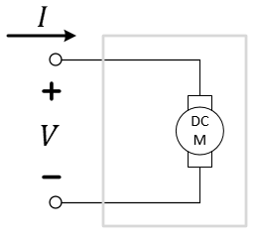
Figure 1: The motor as a mysterious circuit-in-a-box.
In an earlier Falstad simulation, we were instructed to model the motor as a simple fixed resistor, $R_{m}=30 Ω$. Where did that number come from? Does it even come close to modeling the complexities of a real motor? Today we’ll look at the voltage-current relationship of a real DC motor and see how it differs from that of a resistor. We’ll develop a simplified linear model of the motor that we can use for basic predictions.
A basic idea for generating the IV characteristic for the DC motor is shown in Figure 2. Here, a voltage supply is connected through a variable resistor to the motor in a series circuit. The resistor, $R_{k}$, acts as a current-limiter to generate different operating points $(V_{op},I_{op})$ for the motor. Changing the value of $R_{k}$ provides multiple operating points which will allow for a linear “curve fit” that can then be mapped to a Thevenin model (see the lecture notes and course textbook) for the motor.
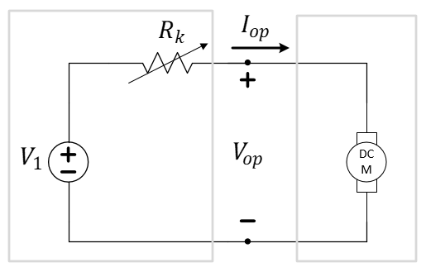
Figure 2: A method for generating IV operating points using a variable resistor.
A practical method for implementing this is shown in Figure 3. Here, we replace the ideal voltage source with our 9-volt battery. We also replace the variable resistor with a resistive network of $k$ resistors, each of value $R$. This provides us a way to control power dissipation in the resistor network without exceeding the individual ratings of any single resistor.
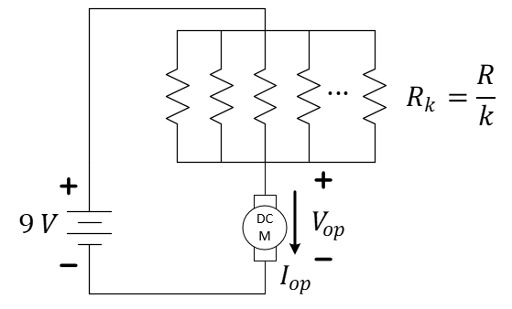
Figure 3: A practical method for generating IV operating points using a resistive network.
Furthermore, “plucking” resistors one-by-one from the network will provide a method for quickly changing $R_{k}=\frac{R}{k}$ by changing the number of resistors in parallel, $k=N, …, 1$. For example, if each resistor has a value of $R=10 kΩ$, then 10 resistors in parallel would have a resistance of $1 kΩ$. Removing one of the 10 would leave nine resistors with an effective resistance of $1.111 kΩ$. Eventually, only one resistor will remain and the effective resistance has grown from $1 kΩ$ all the way to $10 kΩ$. Therefore, we can quickly obtain 10 different operating points for the motor.
Warning! The Keysight scope probes share a common negative terminal as both are connected to earth ground through the MAINS power outlet. If using the Keysight scope, considering measure $V_{op}$ with the opposite polarity so that the negative probes of the oscilloscope’s two channels are on the same node (the node between the resistor network and the motor). This adjustment is shown in Figure 4.
Less obvious may be that this method also provides the means for obtaining current estimates without the use of an ammeter. Using $R_{k}=\frac{R}{k}$ for $k=N, …, 1$ resistors of nominal value $R$ each, we can use Ohm’s law to find the operating current $I_{op}=\frac{V_{k}}{R_{k}}$ as shown in Figure 4. You can use the oscilloscope to measure both values, $V_{op}$ and $V_{k}$, for each number of resistors, $k=N, …, 1$ as resistors are removed from the network.
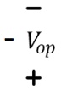
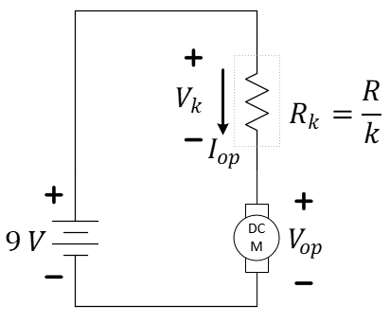
Figure 4: A practical method for generating IV operating points using a resistive network.
- Review your material from the circuit simulation you did for resistive networks (Resistor-Network Power Ratings). What is the smallest single ¼-watt resistor from your kit that will remain under the power rating assuming the motor can be modeled as an Ohmic device with $R_{m}=30 Ω$? Comment: We are making the point that a single resistor from your kit might not allow a high-enough operating current without going beyond its power rating.

- Based on your previous answer, what resistor value in your kit would be most appropriate to duplicate $k$ times in parallel in this resistor network?

- Using this value for $R$, complete the corresponding table column for $R_{k}$ below.
$$k$$ | $R_{k}$ (est) | $$V_{k}$$ | $$V_{op}$$ | $I_{op}$  (calc) | Notes:
10
9
8
7
6
5
4
3
2
1
Table 1: Table of data for determining multiple operating points of a DC motor.
Connect the circuit as shown in Figure 3, using the 9-volt battery (or, if in lab, an alternative power source), your choice of $R$ (repeated) in the parallel-resistor network and one of the drive motors on your car. You do not need to remove the motor from the chassis. Instead, prop the car by placing it something small (like block of wood, a coaster, or a deck of cards) to keep the wheels off the ground.
Run your motor for 2 minutes to warm it up. This should help you get more consistent results in your measurements. Use two channels from your oscilloscope to observe the voltages $V_{k}$ and $V_{op}$ as shown in Figure 4 (reversing the direction $V_{op}$ is measured if using the Keysight oscilloscope). Starting with $N=10$ resistors in the resistive network, use either the voltmeter or the oscilloscope to measure voltages $V_{k}$ and $V_{op}$. Repeat as you remove resistors all the way until there is only one resistor remaining.
Suggestions: You can use the extra space on the power rails (redefined, so ignore the color of the rails this time!) to easily place 10 resistors in parallel. Also, if the oscilloscope shows a rather noisy signal due to the operation of the motor, you can place a large capacitor ($1 μF$) across the motor to “clean” the voltage signal. These “round” capacitors have a polarity that must be followed with the shorter wire also marked with a negative sign. Be sure to attach this wire to the negative side of the battery.
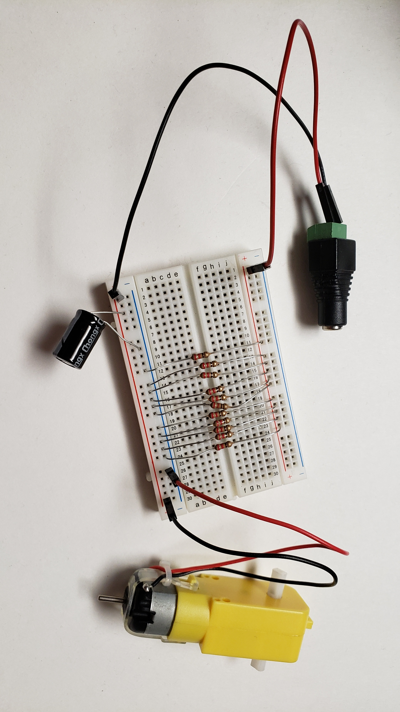
Remember that $V_{k}$ and $V_{op}$ (with the measurement polarities shown in the figures) should sum to the battery voltage (typically somewhere between 8 and 9 volts).

- Add all the measurements for $V_{k}$ and $V_{op}$ as columns to your Table above.
- Compute $I_{op}$ as a column of that table as well using Ohm’s Law.
- Generate a fully-labeled graph of your motor’s IV data similar to that of Figure 5.
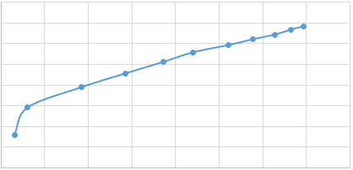
Figure 5: An un-labeled example of what your motor IV graph might appear. You need to label yours!
Perform a linear curve-fit to a portion of this data (much of the data for a moving motor should be nearly in a line). You may construct this linear approximation in any of several ways. You may use a straight edge to draw your linear curve-fit on your printout. In MATLAB, you might use the polyfit command to do a first-order (n=1) fit to that data. In Excel, you can create a scatter plot of only the linear portion of your data, select the data on the plot, and then right-click to Add Trendline… The properties of the trendline can be extended to include the voltage-axis zero crossing.
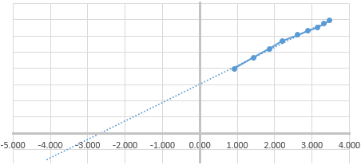
Figure 6: A partially-labeled example after a linear-curve fit has been applied to the moving-motor data.
- Include a plot of your measured IV data along with the linear fit similar to Figure 6.
- Determine a linear equation (slope-intercept form) corresponding to the linear curve-fit generated. Explain how you found the missing values below.
While Moving: $I=$_________$V+$__________
- Using this equation, determine a Thevenin-equivalent circuit for your motor to model it when it’s moving. Show your work. Comment: Here, $V_{op}$ would be the voltage across the Thevenin terminals at the operating point, that is, across the terminals of the series combination of $V_{T,m}$ and $R_{T,m}$.
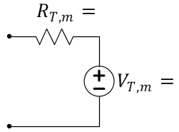
Figure 7: Record your estimates of $R_{T,m}$ and $V_{T,m}$ for the Thevenin model of the moving motor in the figure above.

- Assume that the battery is rated at 500 mAh. How long will your battery last if powering two parallel motor circuits with each motor carrying 110 mA?
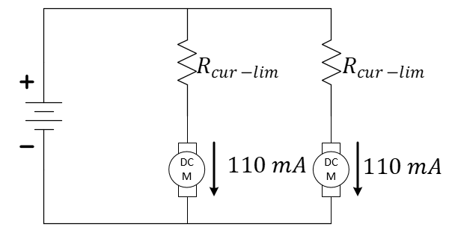
Figure 8: Running two motors in parallel.

