Inverting Amplifier using the LM358

Outline
Very often you will find yourself in need of a way to provide gain (amplify) to a voltage signal. Often, this is one aspect of a process called “signal conditioning” where the signal is conditioned to properly drive the next device within a system. This module will guide you through the procedure of using an LM358 operational amplifier (Op Amp) to provide gain to a small voltage signal.
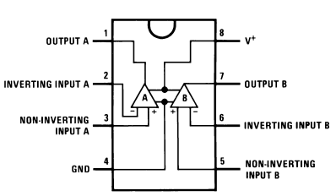
Figure 1: Pin configuration and Functions of the LM 358 Op Amp. Source: Figure 5.1 of datasheet
Figure 1 shows the pin configuration of the LM 358 Op Amp. Although the power supply labels (at pins 4 and 8) suggest the chip should be powered by a single power supply, we will be using a dual-supply configuration where a second battery allows us to apply $-9 V$ to pin 4 and $+9 V$ to pin 8. This will allow us to operate “above and below” our nominal ground reference and will lead to simplified analysis and a build with fewer electronic components. Note that there are two Op Amps contained in each IC.

Learning Objectives
- To interpret critical information from the LM358 datasheet.
- To use node-voltage analysis to analyze an operational amplifier circuit.
- To build an inverting amplifier based on the LM358 operational amplifier.
- To empirically determine the input resistance of an inverting amplifier.

Prerequisites
- Experience with ICs and schematic-to-breadboard circuit builds.
- Experience from lab with use of the function generator including adjustment for “high-Z” mode.

Parts Needed
- (1) LM358 Operational Amplifier (there are 2 per IC)
- (1) $2.2 kΩ$ resistor
- (2) $10 kΩ$ resistors
- (1) $100 kΩ$ resistor

Resources
Datasheet: https://www.ti.com/lit/ds/symlink/lm258-n.pdf?HQS=dis-mous-null-mousermode-dsf-pf-null-wwe&ts=1680032684902&ref_url=https%253A%252F%252Fwww.mouser.co.il%252F
Tutorial at All About Circuits: https://www.allaboutcircuits.com/video-tutorials/the-basic-op-amp-inverting-amplifier/

Short Op Amp Tutorial

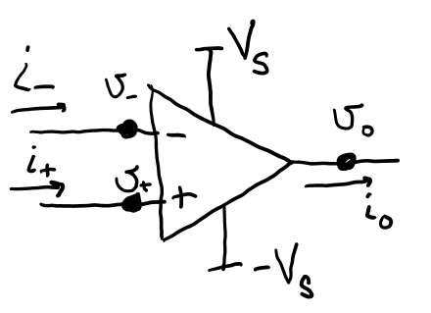
Figure 2: One circuit schematic diagram of the Op Amp that explicitly shows the power supply configuration.
The Op Amp (see Figure 2) is an interesting device. It is designed to amplify the difference between node voltages $v_{+}$ and $v_{-}$, the voltages as the non-inverting and inverting input terminals. Mathematically, $v_{o}=A\left(v_{+}-v_{-}\right)$. But not just a little amplification, a LOT of amplification. The amplification value, or so-called open-loop gain, $A$, is super large, $A≈100,000$. But since the power supply is too modest to support enormous voltages, the Op Amp would most likely not be able to do this. The output $v_{o}$ would merely reach something close to the supplied power and stop. Instead, external circuitry is added to control the amplifying nature of the Op Amp and place the amplification within reasonable bounds. What you really need to know as a designer is how to model the Op Amp behavior such that your analysis is suitably accurate. Here, in simple terms, is what you need to know:
- The voltages at the two input nodes differ only by very tiny amounts (when the connections to the leads provide linear negative feedback as it does in many basic op amp circuits). In fact, you can assume that $v_{-}=v_{+}$ when you apply nodal analysis to the circuit.
- The input resistance as you look into the inverting and noninverting terminals is very large. So large, in fact, that you can assume that $i_{-}=0 amps$ and $i_{+}=0 amps$ when you apply nodal analysis to the circuit.
Node-voltage analysis is commonly used to evaluate Op Amp circuits.
Let’s summarize: You will likely apply node-voltage analysis to solve an Op Amp circuit’s behavior and to do so you will use the Op Amp approximations in the following box.
Op Amp Approximations:
$$v_{-}=v_{+}$$
$$i_{-}=0 amps$$
$$i_{+}=0 amps$$

Let’s also make sure you understand the situation on the power rails. We will be using a dual-supply system, meaning it will take two voltage supplies to generate the $+V_{S}$ and the $-V_{S}$ voltages. Notice in Figure 3, that this means the negative terminal of the “upper” voltage supply needs to connect to the positive terminal of the “lower” voltage supply. We recommend that you use orange wires to represent (connect to) the $-V_{S}$ power rail. This may prevent you from making the mistake of thinking it is also connected to the red power rail. Shorting those two rails together would cause a total of $18 V$ to be shorted! Please take your time, check your circuit, and be careful!

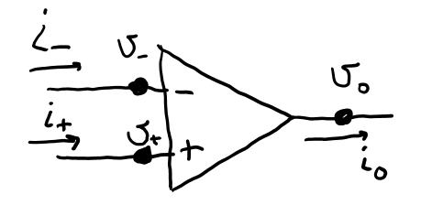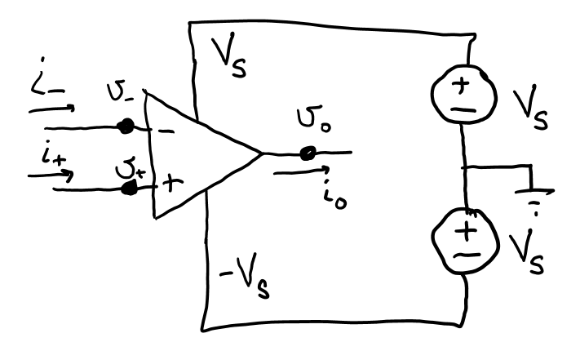
orange wire
black wire
red wire
Figure 3: Three schematics of an Op Amp with dual-supply configuration. Clockwise from top-left: power supplies not shown; power rails shown; power rails explicitly showing the power supply configuration necessary.

Analysis of Inverting Amplifier
Let’s try out our analysis on a real Op Amp circuit. Consider the schematic in Figure 4. Here, there is a resistor, $R_{1}$, between the input $v_{in}$ and the inverting terminal of the op amp $v_{-}$. There is another resistor, $R_{2}$, that provides feedback from the output to the inverting terminal (we might call this negative linear feedback making the op amp approximations valid).
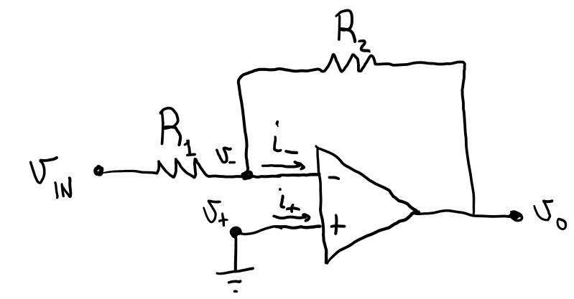
Figure 4: An inverting amplifier.
- Using Figure 4 and your Op Amp approximations, find these values (explain):
$$i_{+}= \\ i_{-}= \\ v_{+}= \\ v_{-}=$$Great! You are well on your way to solving this circuit analysis problem. Next, consider Figure 5 where we have added a node marker (imagine a balloon) on which we want you to apply Kirchhoff’s Current Law.
- Use Nodal Analysis to find a relationship between $v_{o}, v_{IN}, R_{1},$ and $R_{2}$. Solve for $v_{o}$ in terms of $v_{IN}, R_{1},$ and $R_{2}$. It should be of the form $v_{o}=G\left(R_{1},R_{2}\right)×v_{IN}$, where $G\left(R_{1},R_{2}\right)$ is a voltage gain formula that depends on the values of the resistors. Show your work.
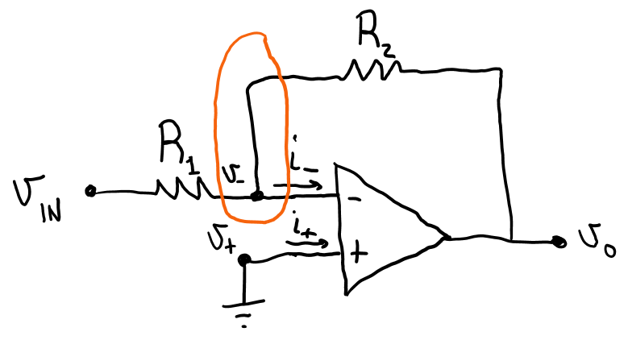
Figure 5: Perform nodal analysis on the node indicated in the inverting amplifier shown here.

Build and Verification
Build the circuit of Figure 4 (Figure 5). Do not connect your batteries until the circuit has been built and double-checked by a teammate. You can use both Blue (black) power rails as the ground-reference node but use one red rail for $+V_{S}$ and use the last power rail for your orange-branded $-V_{S}$ voltage.
- Use $R_{1}=10 kΩ$ and $R_{2}=100 kΩ$ in your circuit.
- Build this circuit using two 9-volt power supplies to drive the Op Amp, but do not plug them in yet.
- For $v_{IN}$, configure the function generator to provide a sinusoid with a peak-to-peak amplitude of 100 millivolts. Use “high-Z” mode. Note: Remember that high-Z mode only changes the readout of the voltage to agree with the internal “Thevenin” voltage source and that the Thevenin resistance of the function generator is always $50 Ω$ no matter if the function generator is in high-Z or $50 Ω$ mode.
Simultaneously measure $v_{o}$ and $v_{IN}$ with two channels of the oscilloscope so that you can view them together. When you are sure your circuit is properly constructed, you may plug in your power supplies and watch the oscilloscope to ensure you see what is expected. If anything appears wrong or “smells hot,” immediately unplug your power supply and check over your circuit for errors.
- Include a screenshot of your oscilloscope showing both voltages.

Datasheet
- From the datasheet, determine the limits on the supply voltage(s) that might be applied to the Op Amp for our particular application. Are we staying within bounds by using two 9-volt supplies?

Thevenin Input Resistance
What does the input see looking into an Op Amp circuit? Let’s find out! Remember, with as few as two data points, we can generate a Thevenin equivalent for a circuit with linear behavior. If we assume the circuit can be modeled with $V_{T}=0$, we only need a single data point to find the equivalent resistance! From the previous setup, you have already implemented Figure 6. Record the peak-to-peak voltage of $v_{IN}$ and compare it to the peak-to-peak voltage that you set on the function generator. We’ll call that voltage $f(t)$.
- Based on this measurement, what is the input resistance of the inverting amplifier? HINT: See Figure 8 to see how the voltage-divider rule may help you to compute a value for the resistance seen looking into the Op Amp circuit. We can call that input resistance the “load resistance,” $R_{L}$, because it offers a load to our Thevenin source circuit. Show your work.
$$R_{L}=________________kΩ$$
Comment: Your calculation in this question will be highly subjective to error. Because the $50 Ω$ resistance of the function generator is so much smaller than what we anticipate for $R_{L}$, small variations in $V_{T}$ (by bumping the circuit) can cause strange estimates for the load resistance.
Figure 6: Test circuit to determine input impedance of inverting amplifier.
Let’s repeat this experiment but add a $10 kΩ$ resistor in series with the function generator (see Figure 7) so the Thevenin equivalent of the source to the left of $v_{IN}$ has a resistance of approximately $10.05 kΩ$.
- (continued) Again, measure the peak-to-peak voltage of $v_{IN}$ and, again, estimate the input resistance of the inverting operational amplifier. Show your work (always).
$$R_{L}=_______________________kΩ$$
- (continued) Repeat one more time with a $2.2 kΩ$ resistor (such that the source would be around $2.25 kΩ$ total).
$$R_{L}=_______________________kΩ$$
Figure 7: Test circuit to determine input impedance of inverting amplifier.
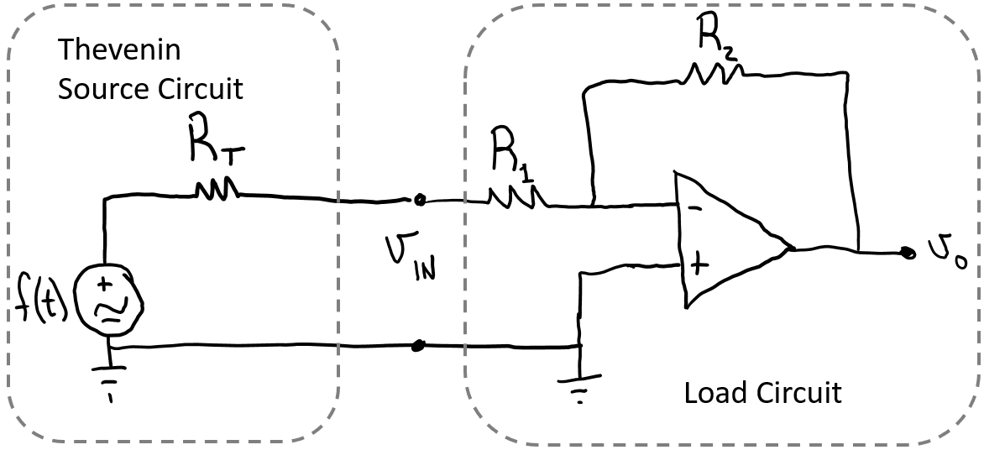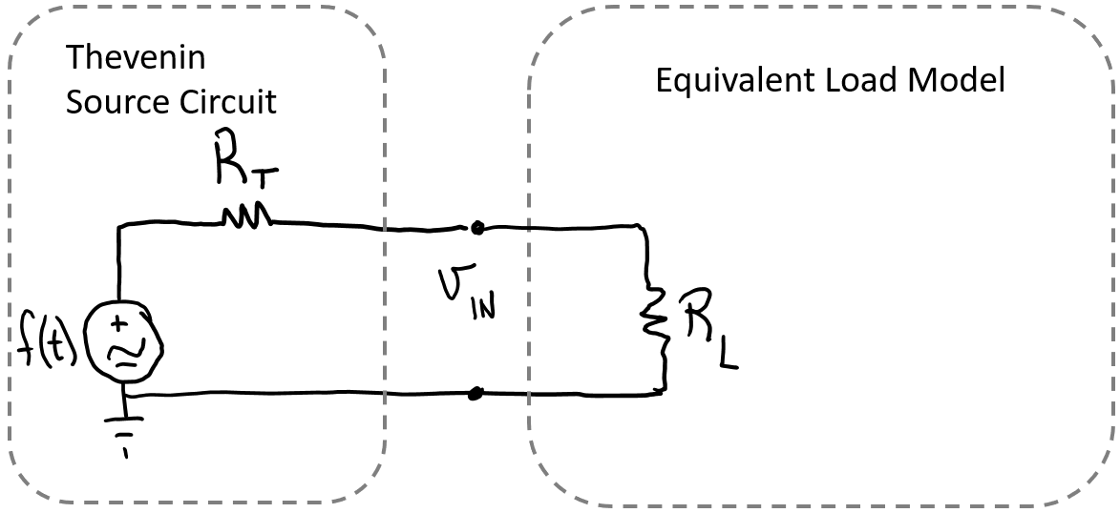
Model
Figure 8: Modeling the load circuit as a load resistance.

Discussion
- Assume, during the building of your final project, that your source circuit to the inverting amplifier of Figure 4 has a Thevenin resistance of $2 kΩ$. What amplification of the Thevenin source, $f\left(t\right)$, should you expect from the inverting amplifier? Explain your answer. HINT: Think about your $G\left(R_{1},R_{2}\right)$ and that $v_{IN}\left(t\right)$ is now $f(t)$.
- Name two (or more) ways that the amplification of your circuit can be increased.

