Straight-Run Car with Speed Control

Learning Objectives
- Apply multiple circuit design techniques to build a car with a knob to make it track in a straight line and another knob to control its overall speed.

Prerequisites
You should have completed the MOSFET-based Logical AND exercise which explains the operation of the two-nMOS logical-AND circuit of Figure 1b. In this design, the motor only runs when the inputs at each of the nMOS gate terminals are “high”.
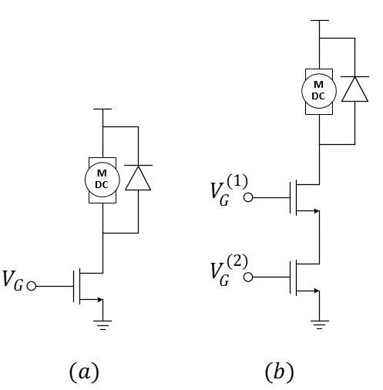
Figure 1: (a) nMOS motor-drive circuit and (b) a two-nMOS logical-AND circuit for “joining” two PWM signals.
Once we have the basic structure of a nMOS-based logical AND motor drive circuit, we can think of multiple uses. For instance, suppose we have a car that turns slightly to the right because the left wheel runs slightly faster than the left. We could use a PWM signal and its “inverse” to slow the left wheel and speed the right wheel to make the car run straight using the traditional single-nMOS motor drive for each wheel. If we also find that we want to slow down both motors, we could generate another PWM signal fed into a second nMOS transistor on each wheel and reduce the duty cycle to slow both wheels simultaneously. To ensure that the two PWM signals work together, we should use frequencies that are an order-of-magnitude different. This is demonstrated in Figure 2 for one of the wheels showing the PWM signal for the speed control to be a factor of 8 times larger than the frequency of the PWM used for wheel balance.
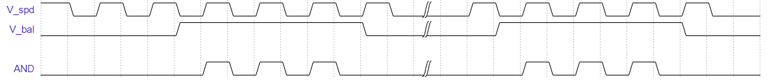
Figure 2: Example: Increasing the duty cycle of either $V_{bal}$ or $V_{spd}$ will change the output of the AND to drive the corresponding wheel at a higher speed allowing either input to achieve its intended purpose.

Procedure
This design is for an advanced motor-control circuit and not just for simple push-button inputs. Consider Figure 3 that includes an adjustable wheel-speed balance potentiometer combined with speed control. You should recognize the familiar motor-drive circuits as well as two oscillators and two copies of the logical AND. This idea should open a wealth of potential robotics projects! Build it now.
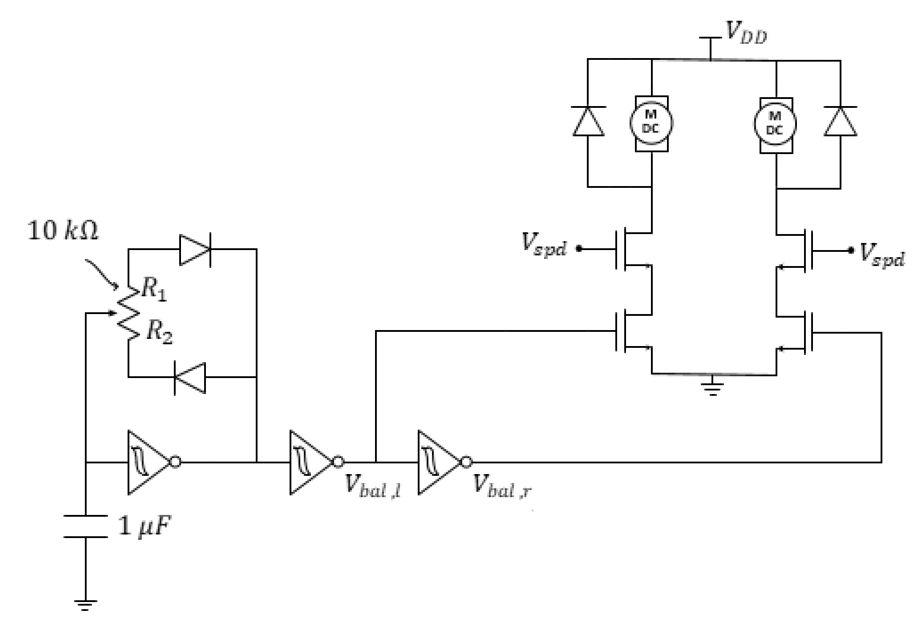
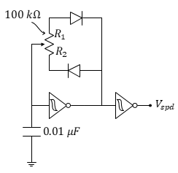
Figure 3: PWM-based wheel balancer plus speed control. The speed control circuit is drawn separately for clarity but notice that the nodes labeled $V_{spd}$ must all be connected.

- Demonstrate to your TA the speed control and wheel-balance operations of Figure 3. Use an oscilloscope in your demo to monitor MOSFET gate voltages as you see appropriate for the explanation.
We’ve learned how to build a light-seeking car, balance the wheels, and do overall speed control. We’ve even learned how to combine two of these features (speed control with wheel balance). Now answer these questions!
- Use a circuit schematic (similar to Figure 3) to explain how you could build a light-seeking car with speed control.
- Use a circuit schematic to explain how you could build a light-seeking car with speed control and compensation for manufacturing differences in motor speeds (a.k.a. wheel-balance).

