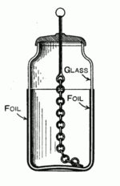
What is Capacitance?
A capacitor is anything that is capable of storing electrical energy. You have capacitance! In fact, you are a great capacitor as your cat/dog/other person knows when you touch them after walking across a carpeted floor during a dry, cold winter. One of nature’s most spectacular displays demonstrates the ability of the ground and surrounding atmosphere to store enormous amounts of electrical energy. If the energy of lightning could be harvested a single strike contains the equivalent energy content as 150 gallons of petroleum. The breadboard you use for this course also has capacitance; in fact, it has many metal plates separated by the insulating injection-molding material…that’s pretty much a capacitor, right?

So what makes an electronic device a 'capacitor'? One attribute seems to be the ability to assemble and hold a large amount of charge isolated in one location so when you need some electrical energy you can discharge some of the charge to light and LED, power a small motor, etc. During the lecture you learn about an instrument named the Leyden jar – this is an example of a device designed to be a capacitor that stored the most electrical energy in the smallest space possible given the current methods of fabrication.
Leyden Jar – the Leyden jar is not named after a person – at least not directly. It was first invented in 1745 by Pieter van Musschenbroek at the University of Leiden in the Netherlands. The name Leiden was anglicized as Leyden.

The Leyden jar was made of a jar covered by metallic foil on part of the outside and on the corresponding part of the inside of the jar. The key feature of this configuration was that two pieces of metal NOT connected to one another were positioned very close to one another separated by a good insulator – glass. The jar was usually corked with a top where a metal rod was inserted and connected (in most drawn figures of old Leyden jars) by a metallic chain to the inside conductor. This connection was used to both charge and discharge the Leyden jar.

Given the objective of designing a device that can hold as much charge as possible let’s look at a stylized picture of the essence of the Leyden jar/capacitor starting with a single metallic plate (see Figure 1) that is a model for the inside foil lining connected to the chain and rod assembly. The capacitor can be charged by touching one of the plates with a material known to contain an excess of electrons. Once the plate is charged potential energy can be stored if the plate is not discharged by touching another conducting material.

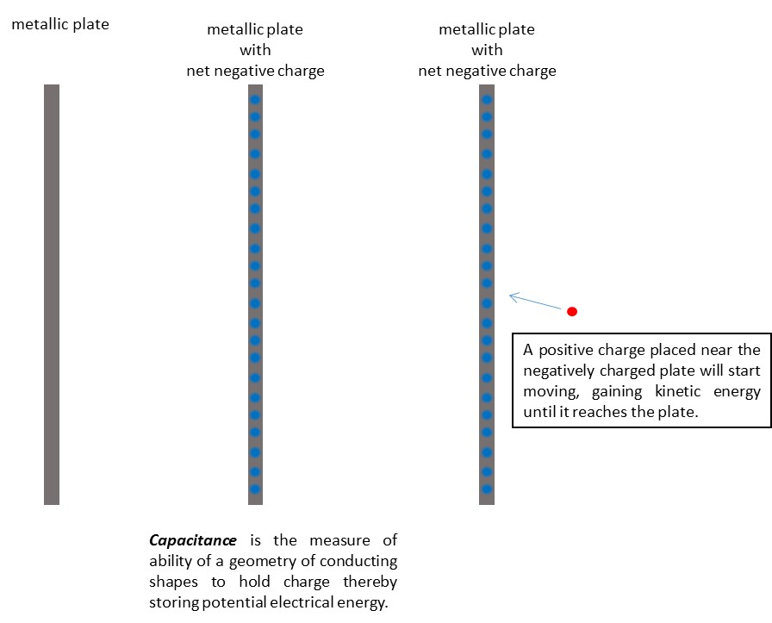
Figure 1: Storing electrical energy by charging a single metal plate. (a) uncharged plate (b) charged plate, and (c) charged plate attracting a positive charge

If a second metallic plate is moved close to the charged plate the field is intensified and mostly confined to the area between the plates – hence the geometry of the Leyden jar and most other capacitors. This potential energy can be tapped by connecting a device – a light bulb for, example – between the metallic rod at the top and the outer conducting foil. Or if a positively charge particle is placed near the plate it will move towards the plate because the charge on the plate influences any charged particles that come near.

Capacitors that are used for various purposes in electrical circuits are all designed using the same basic geometry – two pieces of conducting material separated by a non-conducting material. To understand what circuit designers mean when they say capacitance let’s look at the simplified view of the geometry of a capacitor as two parallel metallic plates. This is the same picture you will see in your physics, circuits, and electromagnetics classes. It is this geometry depicted in the circuit symbol for the capacitor (see Figure 2).
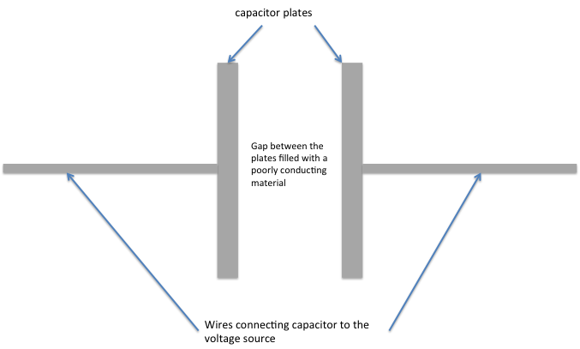
Figure 2: Basic geometry of a capacitor

When the capacitor is hooked up to a voltage source the electrons flowing from the voltage source start piling up on one of the capacitor plates. Initially, the voltage across the plates is $0 V$ until the charges start accumulating. Since the capacitor plates are so close to each other the electrons hitting one plate push electrons off of the other plate leaving behind positively charged vacancies. It appears that current is flowing even though there is a gap between the conducting plates no electron could breach (see Figure 3).

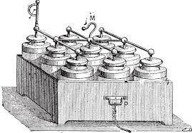
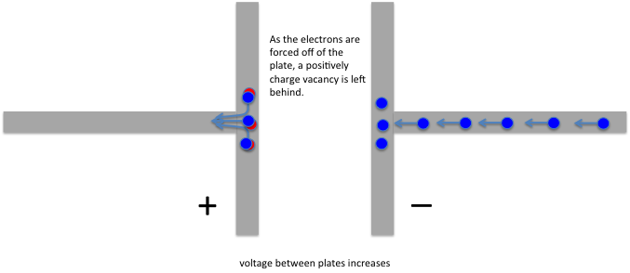
Figure 3: Electrons are flowing onto the rightmost plate pushed along by a $1 V$ voltage source connected to the capacitor.

A bank of nine Leyden Jars used to store electrical energy circa 1895

This process continues but as more electrons accumulate it becomes more difficult to add each one because of the presence of the other charges already on the plate. The accumulated charge sets up a voltage across the gap so the force needed to add more electrons increases. The process slows down – in a given time interval fewer and fewer electrons are added, and therefore fewer positively charged vacancies are created. The increase in voltage also slows down.

After a finite time interval the voltage cross the capacitor matches that of the source (see Figure 4) except with the opposite sign and the process stops. If the voltage source remains constant, current will no longer flow, and the voltage across the capacitor remains constant as well. If the source is disconnected from the capacitor the stored charge should remain and can be stored to be used as a source at a later time. Storing charges in a bank of Leyden Jars was one of the first ways scientists used to store electrical energy.

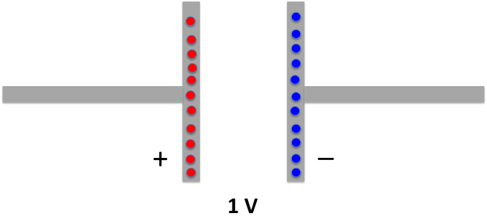
Figure 4: The capacitor is fully charged when the charges on the plates have created a voltage that is the same as the charging voltage source.
Capacitance is defined as the amount of charge that any given geometry of conductors can hold for a given voltage. Mathematically this can be expressed as capacitance equals charge over voltage, $C=Q/V$, or alternately, $Q=CV$. Since most capacitors at steady-state are maintaining an amount of charge that is nowhere near the limit of the material, the capacitor has a linear relationship between the total number of electrons and the voltage across the plates. Since the number of electrons on one plate equals the number of positively charged vacancies on the other plate, Q in this equation refers to the amount of charge on either plate. Since capacitance is not negative $Q=\left|Nq\right|$ where N is the total number of charges and q is the charge of each electron or positively charged vacancies.
The units of capacitance, like resistance, reflects the basic definition of the units. Since the I-V relationship for a resistor is $V=Ri$ the constant R is measured in Ohms which is equal to (Volts/Amps). The I-V relationship of the capacitor is $i=C\frac{dV}{dt}$. This is a differential equation that shows that the voltage and current have a time dependence. Recognizing that the current is really $i=\frac{dQ}{dt}$ the relation is written as $\frac{ΔQ}{Δt}=C\frac{ΔV}{Δt}$ where the derivatives have been replaced with the delta $Δ$ notation. The relationship simplifies to Q=CV making the unit of Farads (capacitance, C) equal to Coulombs/Volt ($Q/V$).

Procedures

Energy Storage Devices
While there are many different types of capacitors used in electronic circuits the concept of a thing having capacitance applies to all matter. Some structures are better at storing electrical energy than other things. In the next section you will play with the parameters that are considered when fabricating a capacitor – first let’s look at how electrical energy is stored. You will be using a capacitor – one like you might find in your computer or other electronic equipment.
This section will also give you respect for some safety issues that are associated with using capacitors. Before flat screen televisions there were TVs that used Cathode Ray Tubes (CRT) as the method of projecting the image. Older models used some very high voltage, high power capacitors that were so effective at holding their charge that repairmen servicing a broken TV had to make certain to discharge all the capacitors. There are many stories of people dying from touching the nodes of a capacitor that was assumed to be “off” even if the power was removed as long as a month before. Our little capacitors are however pretty safe.
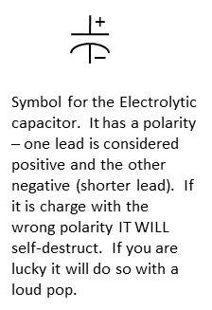
- On a breadboard use build the following circuit using a red Light-Emitting Diode, a $10 kΩ$ resistor, and an electrolytic capacitor with a labeled capacitance of $100μF$. Below is the schematic and a suggested layout on the breadboard.

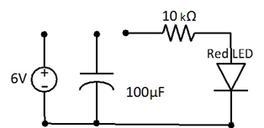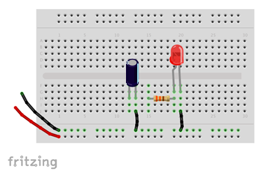
- (b)
Figure 5: The (a) schematic and (b) physical diagram of a partial circuit for capacitor charging and discharging.
This circuit is incomplete because you will connect it in two different configurations.
(a) (b)
Figure 6: The (a) schematic and (b) physical diagram of for charging a capacitor.

Step 1: Charge the Capacitor
- Use a voltage supply that has a value of anywhere from $6-10 V$.
- Connect the power supply to the breadboard as shown in the figure above – along the breadboards power buses.
- Connect the series resistor/capacitor circuit to the $6 V$ supply.
- Disconnect the voltage source and return the circuit to its original disconnected state.

- The capacitor should be charged. Since the capacitor is outwardly undemonstrative let’s check. Using the DMM measure the voltage across the capacitor and record the value.
Step 2: Light the LED
The capacitor is now holding enough charge such that the voltage across the leads is at least $5 V$. In ECE 110, you will study diodes. The LED is a special diode that lights up when the voltage across the terminals of the device reaches a certain value. Since the LED takes so little current to light up it is ideal for projects and the lighting needs of the future. The red LED only requires about $1.7 V$ to turn on.
- Connect the capacitor to the LED (through the resistor) making certain the polarities line-up as shown in the schematic.
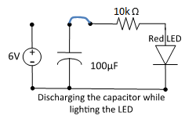
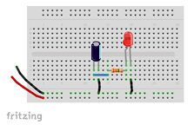
Figure 7: The (a) schematic and (b) physical diagram of for charging a capacitor.

- Describe what you observed. Explain the behavior of the LED. Charge and discharge as many times as you wish.
- Measure the voltage across the capacitor and record the value. Knowing that the LED is off in the sense that it draws very little current once the voltage across the device is smaller than a given threshold – explain the value you obtained.

Effect on time-varying signals
Besides storing energy the capacitor has another characteristic that is exploited in many circuit designs. Though more and more signal processing can be done inside the computer, hardware filters are still used to modify a signal like that coming from the terminals of your car’s radio antenna. The capacitor has time-dependent behavior – mathematically this means that the I-V relationship includes a derivative $I=C\frac{dV}{dt}$ where C is the capacitance. If the time variation of the signal is fast enough the capacitor cannot fully charge and discharge completely. Let’s see how this affects a square wave. The square wave is the most difficult signal because of the abrupt changes in voltage and is often used to show the transient behavior of circuits.
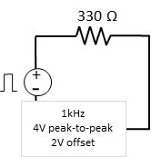
If a resistor is connected to the signal generator from Ohm’s Law you would expect to see the square wave supplied by the signal generator and the current flowing through the resistor $I=\frac{V}{R}$ so let’s test how the individual components, the resistor and capacitor, affect the square-wave.
- Build a new circuit with only the resistor driven by a square wave (use a function generator) as instructed.
- Probe the voltage across the resistor with channel 1 of the oscilloscope.
- Draw or plot the waveform. Describe the waveform.
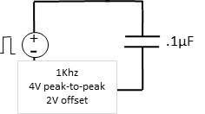
- Now take out the resistor and put the square wave signal across one of the capacitors that comes in your kit. Use the one labeled 104. In the weird and wacky world of capacitor labeling the number 104 means that the capacitance is 10*10000 picoFarads or $0.1 μF$. What does pico mean as a prefix?
- Probe the voltage across the capacitor with channel 1 of the oscilloscope.

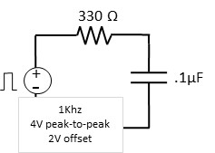
- Draw or plot the waveform on top of the one you drew in the previous question. How are they different? Explain the difference.
- Now put the resistor and the capacitor in series and connect the square wave signal.
- Probe the voltage across the capacitor with channel 1 of the oscilloscope.
- Draw or plot the waveform on top of the one you drew in the previous question. How are they different? Explain the difference.
The resulting waveform when the capacitor is included in the circuit has rounded corners. Where the square wave was crisp and square across the resistor, all the transitions are smoothed when the capacitor is added. When the resistor and the capacitor are both in the circuit the amount of smoothing changes. With larger values of resistance or capacitance it takes longer for the voltage to reach the DC values of 4 or 0V. In fact, by judicious choice of R and C you can control this time interval.
- Increase the frequency of the square-wave from $1 kHz$ to $60 kHz$ while watching what happens on the oscilloscope. Describe what you see and provide an explanation.

Experiment with making a capacitor
The devices we call capacitors are optimized through the choice of the most suitable material and geometry. All capacitors are built using two conducting “plates” in close proximity separated by different materials depending on the type of capacitor. The main factors that determine capacitance involve characteristics that affect how much charge can be stored:

- The surface area of the plates $A$ – often they are both the same size. The larger the area the more charge that can be stored.
- The distance between the plates d – the closer the plates are the more the positive charges mitigate the forces the electrons exert on each other so more charge can be accommodated.
- The material in-between the plates can affect the ability of the capacitor to store charge as well. The material property is characterized by a parameter called the permittivity $ϵ$ that is a measure of how deformable the molecules inside the material are when subjected to electromagnetic forces generated by the charges on the capacitor plates. You will learn more about this concept in your physics and engineering classes.
With easy to use materials – metal plates or aluminum foil and paper – you will explore how the size of the plates and the separation affects the capacitance.
Unfortunately, your lab bench equipment cannot directly measure the capacitance of a device. Such equipment exists but learning to estimate the capacitance of devices without special equipment is valuable as you might not have the proper equipment out in the field. You need a capacitor and your eyes are too old or cannot read the markings, or you forgot the somewhat cryptic labeling convention. Ok so you probably do not have a signal generator or oscilloscope either but this is a worthy exercise.
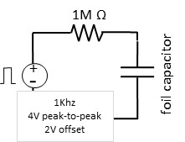
- Build a circuit similar the one used in the previous section except replace the resistor with a 1MΩ resistor and remove the capacitor. The capacitor is to be replaced by one that you build.
- Cut two pieces of aluminum foil the size of a sheet of paper. Make a capacitor by inserting a piece of paper between the two pieces of foil. Ta da a capacitor.
- Attach an alligator clip to each piece of foil. The placement is irrelevant but be sure that the pieces of foil DO NOT touch – or the alligator clips.
- Attach the alligator clips to banana cables which have adapters attached that allow the ends to connect to the breadboard. Insert the foil capacitor into the circuit.
- Apply the 1kHz, 4V peak-to-peak square wave with a 2V offset as the power source as before.
- Probe the voltage across the capacitor on channel 1 of the oscilloscope.
Hopefully, you see a similar waveform on the oscilloscope.
- The capacitance is related to the distance between the plates. Push down on your capacitor and describe what you observe happening to the waveform on the oscilloscope. Explain what you observe. Plot the waveform obtained with no pressure and a wave form obtained while pressing down on the foil.
- Using the same circuit, cut your capacitance in half by using sheets of foil half the original size and continue.
- When you are not pressing on the foil capacitor how does the waveform compare to that obtained in Question 8? Explain the difference.
- Reduce the frequency so that you can use the rise time (and your knowledge of RC time constants) to estimate the capacitance of this last capacitor. Include your equations and math.

