Buttons and Switches and RC Time Constants
How to read the resistor color code: http://en.wikipedia.org/wiki/Electronic_color_code
You will want to learn a good mnemonic like the one here: http://www.orcadxcc.org/resistor_color_codes.html or https://www.allaboutcircuits.com/tools/resistor-color-code-calculator/

Switching a Circuit
Let’s build a circuit that uses two buttons to turn on and off two light-emitting diodes (LEDs). Locate two push buttons from your kit, as well as two red LEDs and two $330 Ω$ resistors. These resistors will have the color bands “orange orange brown” plus an additional band (likely gold) that indicates tolerance. You may use either 4 AA batteries or a 9-V battery for power. Be very careful not to short your battery when building the circuit. Be ESPECIALLY careful not to accidentally short your battery when storing or transporting your circuit.
Using these parts, we will construct the circuit illustrated in the circuit schematic of Figure 1 and clearly explained in the physical diagram of Figure 2. The proper insertion of the button into the breadboard is explained in Figure 3.
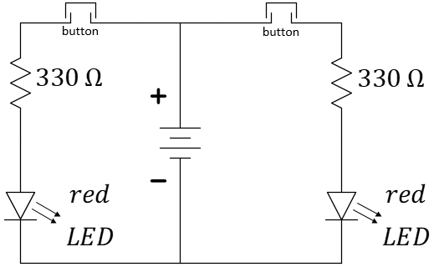
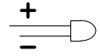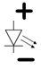
All diodes have an anode (top) and a cathode (bottom). If the LED is inserted in reverse, it will not illuminate as the voltage is increased.
Figure 1: Circuit schematic for switching LEDs.

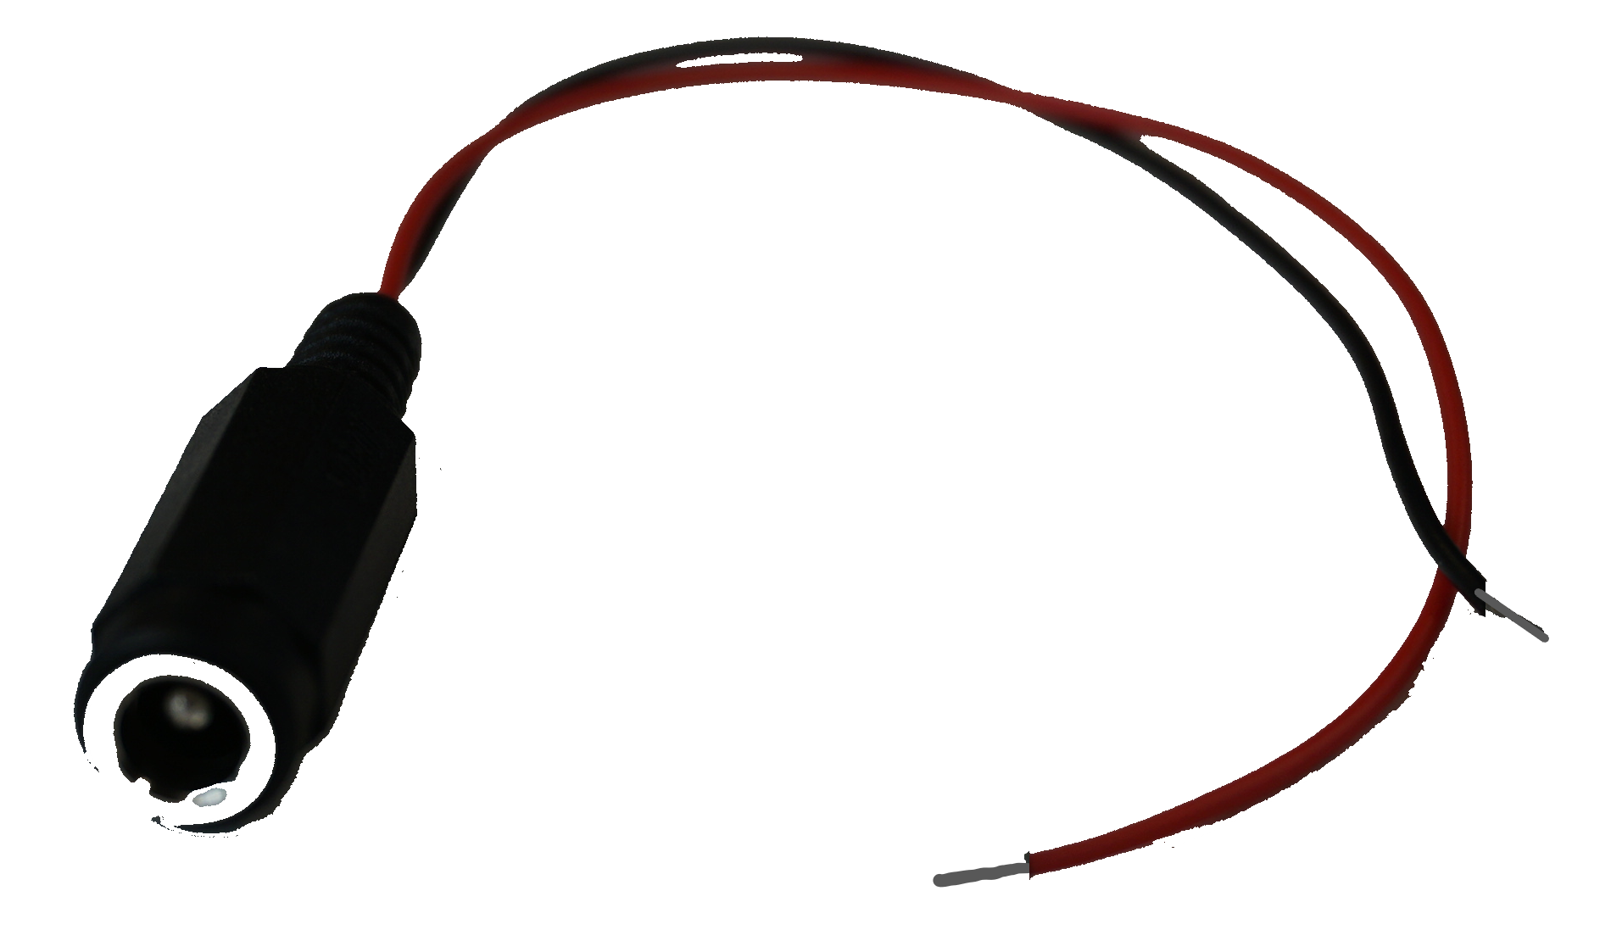
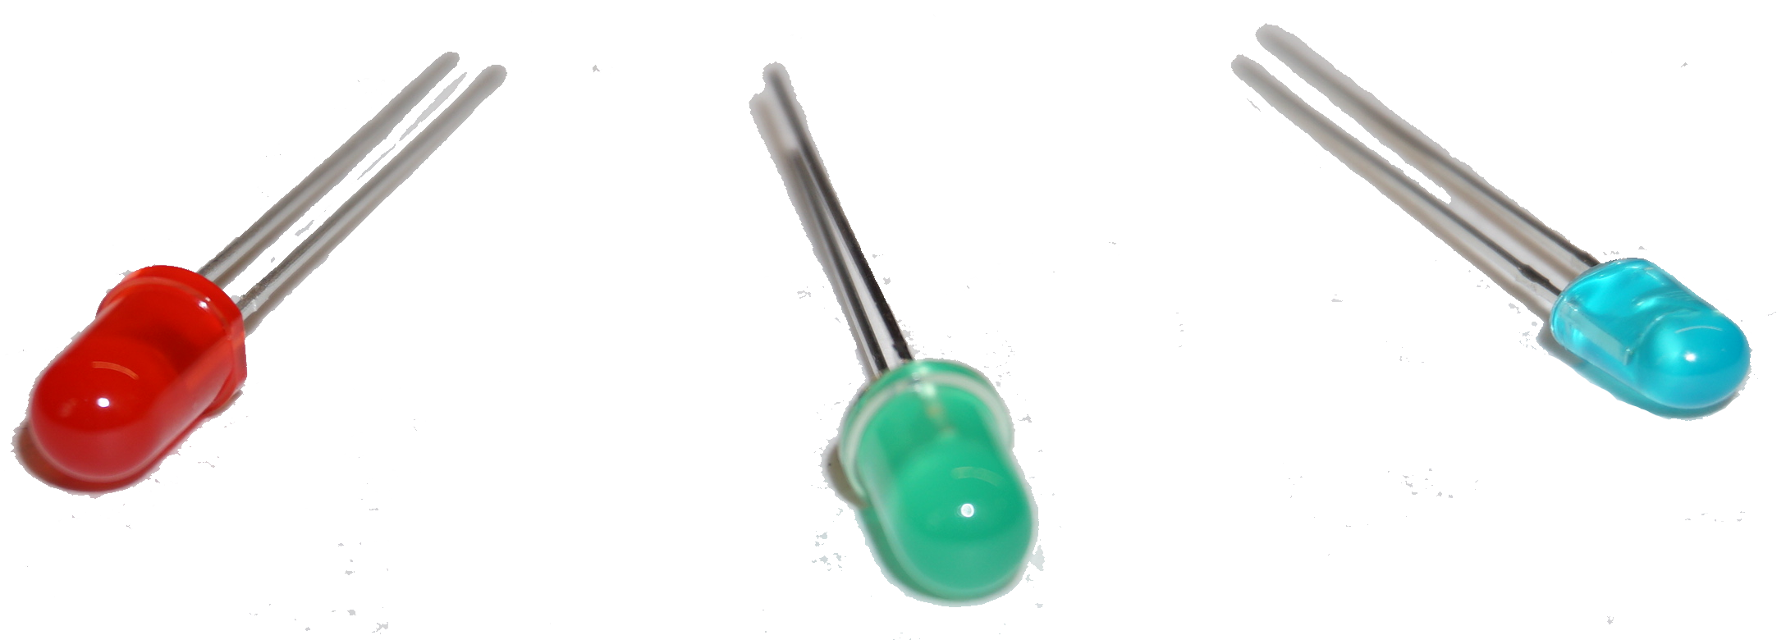
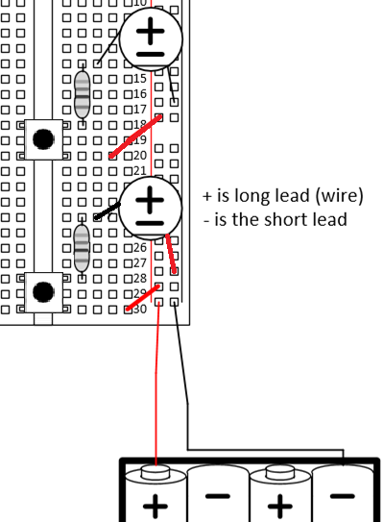

The LEDs of your kit have nice color!

A barrel-to-wire adaptor
Figure 2: Physical diagram for button-controlled motors. The barrel-to-wire adaptor will be needed. The 4xAA battery pack may be replaced by your 9-V battery.
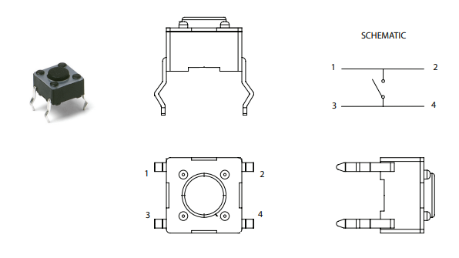
Figure 3: Multi-view projection of the button (adapted from https://www.ckswitches.com/media/1471/pts645.pdf). Within the button, two flat wires span the gap in the middle of your breadboard. These two wires are connected by an internal metal plate (symbolized by the switch in the top-right figure above) when the button is pressed.
Now, take apart that first circuit (the first portion is not graded) and build the circuit of Figure 4. Use $C=1000 μF$ for the capacitor, $R=1 kΩ$ (brown/black/red/gold) for the resistor, and a red-colored LED. Be careful about the orientation of the buttons. Remember that the connection across the button should only be made when the button is pressed. If your LED remains lit with no buttons pressed, your orientation is likely wrong. If the LED will not light, check the polarity (direction) in which it is inserted.
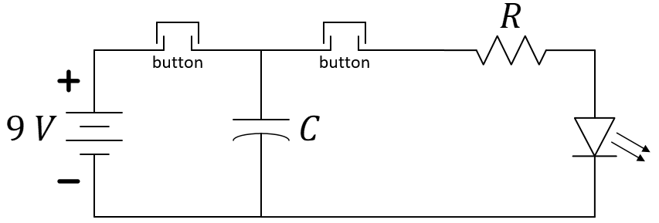
Figure 4: Circuit schematic for examining a time constant without an oscilloscope.
- Explain, using your prior knowledge of time constants, $t_{rise}≈2.2×RC$, why the capacitor should charge very quickly when the button on the left of Figure 4 is pressed. Is $C$ in the equation the same as $C$ in Figure 4? Is $R$ in the equation the same as $R$ in Figure 4? Explain.
- Make a quick estimate how long the LED might remain lit when the rightmost button (only) is pressed. Base your guess on the time constant, $t_{fall}≈2.2×RC$. You need not consider any characteristics of the LED. Again, discuss the values of $R$ and $C$ with respect to the equation and Figure 4.
- Press the leftmost button (see Figure 4) for about 1 second, then hold down the right button. Count how many seconds the LED remains visibly/perceivably illuminated. Repeat. Think about how this compares to the estimate of $t_{fall}$. What do you think accounts for the difference between $t_{fall}$ and the count you just made?
- Add a second $1000 μF$ capacitor in parallel to the first and repeat the process of Question 3. Capacitors in parallel will have an equivalent capacitance of the sum of the capacitance of each. Does your observation support this? Explain.
- Remove the LED and replace it with a wire so the parallel capacitors discharge directly through the resistor. Use Channel 1 of the oscilloscope to view the voltage across the capacitor as it discharges. HINT: Set the Horizontal Scale appropriately so that you can hit the Single sweep on the oscilloscope and have time to hold down the discharge button. Sketch your plot in Figure 5.
Figure 5: Plot the signal that you see on your oscilloscope. Include the voltage and time units and scale.
Do not disassemble this circuit until you have provided a demonstration to your TA for credit!*
*Footnote: If time runs short, the TA might request that you produce a video of your demonstration for submission.

