ECE 530 Problem Set #4 Fall 2015
Due 10/19/15

- Apply the Gauss-Seidel iteration to the system

$$A=\left[\begin{matrix}0.96326 & 0.81321 \\ 0.81321 & 0.68654\end{matrix}\right] b=\left[\begin{matrix}0.88824 \\ 0.74988\end{matrix}\right]$$

Use $x^{(0)}={\left[0.33116 0.70000\right]}^{T}$and explain what happens.

2. Solve problem1 using the conjugate gradient method. What would happen now?

3. For the two-bus case in the Problem 3 of Problem Set # 1, place a transformer with p.u. reactance $X=0.2j$ and the tap $t=1∠5^{0}$ between Bus 2 and the load (introduce a new bus 3). Find the new admittance matrix and the corresponding Jacobian matrix.
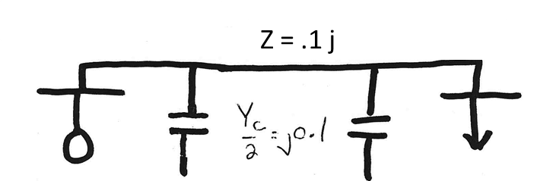
Bus 2
Bus 1

4. For five-bus case (Bus5_GSO) in Problem Set # 2, solve it again using the dc power flow model. Show all your work and compare the solution with the one you obtained using the N-R power flow method.

