Developing an LED and Spectroscopy System for Detecting Aflatoxins in Corn

Our interdisciplinary group of engineering and food science researchers would like to have a student team design and build a reproducible prototype of an LED and spectroscopy system to detect toxins in grain. The long-term goal is to improve the quality of food produced in developing countries by identifying and removing contaminated kernels. Currently, a laboratory setup (pictured below) can detect aflatoxins in single kernels of corn by dropping kernels though an LED light tube connect to a UV to NIR spectrometer. This setup requires manual LED balancing, data-logging, and calibration.

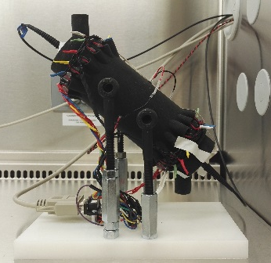
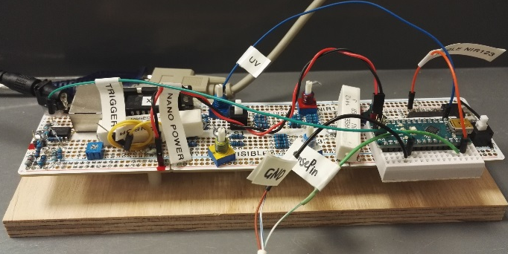

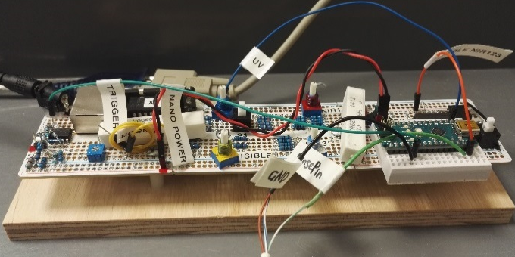
Light Tube LED Driver Circuits
The circuit board and Arduino Nano

The proposed project would involve designing circuitry to automate the LED balancing, detecting kernels, pulsing and sequencing of the LEDs, and obtaining spectrometer readings; ideally with a graphical user interface (laptop, tablet, or possibly a phone). The project would also involve producing a printed circuit board designed for mounting inside a sealed enclosure with the light tube, for easy transport and decontamination.

To move this system towards automated sorting, the project could also include a method for detecting rapidly moving kernels and synchronizing the LED s and spectrometer to automate the system for sorting a continuous flow of kernels. This could include generating a signal for a solenoid to kick out contaminated kernels, via an air pulse or mechanical channeling method, as they are detected (note: the system can be tested with commercial instead of contaminated kernels).

The overall goal is to create a low-cost design that can be replicated to allow international research laboratories to participate in this work. We would then develop sorting systems for use in country.

Please contact John M. Hart for further details: jmhart3@illinois.edu

