Final Report for ECE 445, Senior Design, Spring 2024
TA: Jialing Zhang
01 May 2024
Project No. 73
Tanmay Kant (tkant2)
Aryan Mathur (aryanm6)
Ashwin Provine (provine4)
By

Occupancy counter
Abstract
The document goes through our project that we have worked on throughout this semester. The project we designed and implemented is an occupancy counter to determine how many people are inside a room. It is composed of multiple subsystems and is able to connect with a digital display in order to show the change in room count. The document goes through various aspects of our project, including our block diagram, design, costs, and results. Our project was a success as we satisfied all of the high level requirements.
Contents

1. Introduction 1
1.1 Problem 1
1.2 Solution 1
1.3 Visual Aid 2
1.4 Block Diagram 2
1.5 High-Level Requirements 3
1.6 Subsystem Overview 3
Control Unit Subsytem: 3
Sensor Subsystem: 3
Power Subsystem: 3
2. Design 4
2.1 Design Procedure 4
3. Design Verification 4
3.1 Microcontroller 4
3.2 Sensor 4
3.3 Power 4
4. Costs 5
4.1 Parts 5
4.2 Labor 5
4.3 Total Cost 5
4.4 Schedule 5
5. Conclusion 6
5.1 Accomplishments 6
5.2 Uncertainties 7
5.3 Ethical considerations 7
5.4 Future work 8
References 8
Appendix A Requirement and Verification Tables 9
Appendix B Zone Workings in the Field 10
Appendix C Sensor Accumulation and Decision Making 11
Appendix D Picture of Occupancy Counter Device and Casing 12

1. Introduction

1.1 Problem
In large building environments, managing energy consumption efficiently, particularly for heating, ventilation, and air conditioning (HVAC) systems, presents a significant challenge. HVAC systems often operate on a fixed schedule, with little regard for the actual occupancy of a space, leading to unnecessary energy use and increased operational costs. This inefficiency is especially pronounced in spaces like offices or small meeting rooms due to constant movement. The motivation for the occupancy counter project is to enable more intelligent and adaptive HVAC control by accurately tracking the number of people in a given space. Our experience in the ECE391 Lab (ECEB3026) was a perfect example of HVAC not recognizing the amount of students working late in the lab, with temperature fluctuating constantly. By aligning HVAC operations with real-time occupancy levels, this technology aims to significantly reduce energy consumption and operational costs for large buildings. Achieving precise occupancy counts allows for the HVAC system to adapt its output to the current need, ensuring that energy is not wasted heating, cooling, or ventilating spaces that are not in use or are only partially occupied. Additionally, this system supports a more sustainable approach to building management by reducing the carbon footprint associated with unnecessary energy use.

1.2 Solution
Our project is an occupancy counter for rooms. It will utilize [a] Time of Flight Sensor Module(s) for the recognition of room occupants, where we will either use one module, splitting between two zones, or use two modules in order to determine whether the target is entering or exiting the room. The brains behind the sensor will be a WiFi-enabled Arduino Board that will decide the direction of the person’s transit, keeping track of how many people are present in the room. It will update a web interface that can be connected to by any user. The whole device will be powered by USB power brick(s).

1.3 Visual Aid
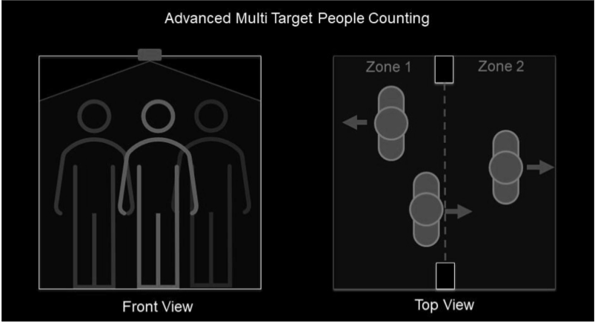

Figure 1: Visual Representation of the working Occupancy Counter

1.4 Block Diagram

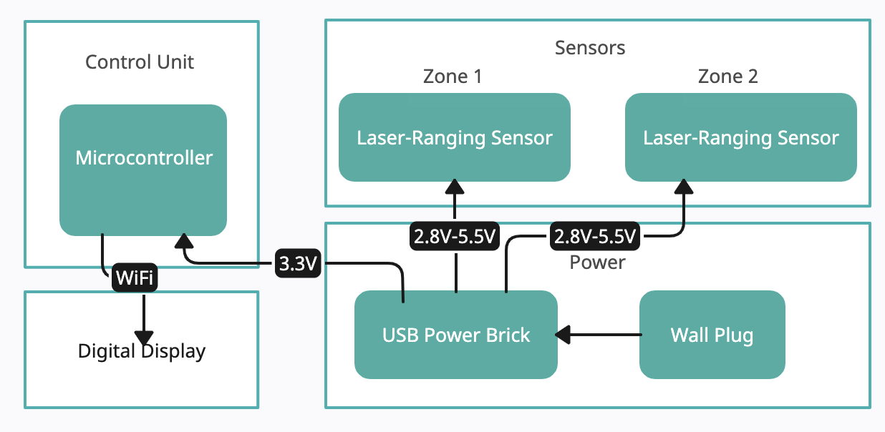
Figure 2: Block Diagram Representation of the Subsystems of the Occupancy Counter

1.5 High-Level Requirements
- Exactness/error of count: the count must be exact for up to six occupants, and correct within plus/minus of one person for up to twelve. Since this project is being used as a dependency for a much bigger system, precision and accuracy are important.
- The actual display should update between two to ten times per minute. This is to ensure that our count is considered live and makes an impact on the energy-saving and HVAC procedures that will ensue.
- Output data will be transferred via a wireless (WiFi) connection to a display. The sensor we are using has a built-in web interface that can be enabled during setup which will allow for universal access for users of the project.

1.6 Subsystem Overview

Control Unit Subsytem:
“The ESP8266 is a high-performance wireless SOC that offers maximum utility at the lowest cost and unlimited possibilities for embedding WiFi functionality into other systems.” This module will be the brain and mouth of our project, where data received will be broken down into a few key components, calculated, and sent out as a summary. The data will be analyzed to decide whether the target is moving from Zone 1 to Zone 2 or conversely. From there, the brain will add or subtract to the room count. Once this is complete, the data will be beamed via WiFi to a digital display (monitor, tablet, phone).

Sensor Subsystem:
“The VL53L1X is a state-of-the-art, Time-of-Flight (ToF), laser-ranging sensor, enhancing the ST FlightSense™ product family. It is the fastest miniature ToF sensor on the market with accuracy ranging up to 4 m and fast ranging frequency up to 50 Hz.” This module acts as the eyes for our project, where the timing of a person crossing the tracked region will be acted upon using a state machine to see the current status.

Power Subsystem:
We use a USB-enabled power brick to provide power to the modules and connect it through a slim and long USB cable. The power for the VL53L1X will be between 2.8V to 5.5V, with the voltage properly regulated by the sensor carrier board while the power for the ESP8266 will be a standard 3.3V input, both powered by DC current. This is arguably the simplest but most important part of the build, as the power must be supplied to both the sensors and the control unit in order for working functionality of the project.

2. Design

2.1 Design Procedure
For our various subsystems, we had a lot of choices in regards to the hardware that we used. Each block of our design was chosen keeping a variety of factors in mind, such as efficiency, compatibility with the other components of the project, cost, availability and accessibility, ease of use, and structural integrity.
We researched other viable alternatives for our microcontroller, but ultimately chose the ESP32866 D1 Mini due to its cheap cost and small size. Some of the other choices were more expensive or larger. Additionally, we found a lot of online resources and support for this piece, which we knew would be useful as we conducted our project build and testing. Lastly, we saw that KiCad had in-built libraries for this component, so we wouldn’t have to rely on some third-party library.
The Time of Flight sensor we chose was similarly due to low cost and ease of use. We knew that regardless of our choice between breadboard or PCB, we would need to keep the sensors light and small, so that they could easily fit on the doorways above the room. We chose the sensor that met our Hertz range requirement as well as the sufficient laser range of 4 meters.

3. Design Verification
For our design verification, we needed to test three main aspects: the microcontroller, the sensors, and the power.

3.1 Microcontroller
We needed the microcontroller to maintain an accurate count of how many people are in the room, so we simulated movements between the various zones while checking the live update on our digital display,.
We ensured to test edge cases such as rapid movements or simultaneous movements from multiple targets.
All our testing passed the requirements we made.

3.2 Sensor
The VL53L1X sensor must accurately detect individuals within a range of up to 4 meters, catering to small to medium-sized rooms. The detection error has to be minimal to ensure precision and accuracy. We conducted field tests to test out the detection range by moving at different speeds and distances up to 4 meters, as given on the sensor specification sheet.
All our testing passed the requirements we made.

Power
The sensor carrier board must regulate the voltage supplied to the VL53L1X sensor within the specified range (2.8V to 5.5V). We measured the voltage output of the sensor carrier board to ensure it falls within the specified range for the VL53L1X sensor. We verified that the ESP8266 module receives an average of around 3.3V input voltage. We also tested the voltage regulation circuit under different load conditions to ensure stability and reliability.
All our testing passed the requirements we made.

4. Costs

4.1 Parts
Wi-Fi Enabled Chip - $5.12 USD
ToF Sensor - $2.78 USD
PCB and wires - provided, estimated <$10 USD

4.2 Labor
We will also include labor costs with a figure of $50 per hour per team member, as that is appropriate for a UIUC ECE graduate: We estimate to each work approximately 10 hours per week. There are 10 active working weeks in the semester since we started officially working on this project until the end of the semester, accounting for Finals week and Spring Break.

4.3 Total Cost
Thus:
(50 dollars per hour per teammate) * (3 teammates) * (10 hours/week) * (10 weeks) = $15,000 in labor cost
A grand total cost of parts summed with labor is $15017.90

4.4 Schedule

Week | Task | Person in Charge
Week of 2/26 | Design Review with teachers and TAs. Deciding the theoretical logic behind the sensor. | All
Week of 3/4 | Begin preparation of the breadboards by soldering long header pins into them. The sensor will be further away from the breadboard, and the zones of detection will not conflict with the walls. Begin the schematics for the wiring diagram and find out how to properly connect components. | Breadboard: Tanmay  Schematics and Wiring Diagrams: Ashwin and Aryan
Week of 3/11 | Spring Break | N/A
Week of 3/18 | We figured out how to properly and safely attach the components to the doorways. We may need to use enclosures, and will have to figure out wire/cable management.  We also finalized the wiring schematics, and the electronic components. | Component attachment: Tanmay  Wiring Schematics:  Ashwin  Wire/Cable management:  Aryan
Week of 3/25 | Begin work on attaching and wiring all the electronic components. We will also begin looking at the requirements and process for the software side. | All
Week of 4/1 | Finished the hardware portion of the project. Worked on the software in terms of figuring out the best and most efficient way to connect our microcontroller to our sensors, and send the information appropriately to the digital display. Ashwin will take the lead on the digital display portion, while Tanmay and Aryan do the other parts. | Software and Digital Display Connection: Ashwin  3D enclosure and microcontroller to sensor connections: Tanmay, Aryan
Week of 4/8 | Wrote the logic for ingesting sensor data, making sense of it, and accordingly sending that information to the display. | All
Week of 4/15 | Completing the coding aspect, mostly debugging issues. | All
Week of 4/22 | Testing, figuring out edge cases, and Project Demo | All
Week of 4/29 | Project Presentation | All

5. Conclusion

5.1 Accomplishments
We were successfully able to create a functioning Occupancy Counter and satisfied all of our high level requirements. Within the sensor subsystem, our time of flight sensor was able to detect motion on both sides of the door and accurately give back the corresponding data dealing with the timing of the zones. We were able to integrate the sensor subsystem to connect with the microcontroller. The internal connections were able to fit into our 3D enclosure so that it was small and compact enough in order to be able to effectively be in use over a door. The wireless connections worked seamlessly as the digital display was able to update simultaneously with the person entering or exiting a room so that it shows an accurate display of the room.

5.2 Uncertainties

5.3 Ethical considerations
Ethics:
With this project, we aim to mitigate potential ethical and safety concerns that could arise. We are improving the effectiveness of safety standards, which corresponds to IEEE’s Code of Ethics Section I.1, which is “to hold paramount the safety, health, and welfare of the public…”. The data obtained through this project is to be processed externally while scanning for people both entering and exiting an environment. It is important to respect the privacy of individuals and their whereabouts, as IEEE’s Code of Ethics Section I.1 mentions how crucial it is, “to protect the privacy of others…”. Our device will detect people who enter or exit a room but will not store or scan any information that could pose any harm to anyone. In order to sustain our functionality while abiding by IEEE’s Code of Ethics Section I.3, which is “to avoid real or perceived conflicts of interest whenever possible, and to disclose them to affected parties when they do exist, we decided that this was the best course of action”.

Safety:
As always, safety is a very critical aspect that our group will consider, so that we can protect everyone’s wellbeing and work smoothly towards a successful and meaningful project. This project involves the use of electronic components such as the ESP8266 module and the VL53L1X sensor, so we have to keep in mind electrical safety. All of our connections should be properly insulated to prevent short circuits or electrical shocks. We will be sure to pay careful attention to the USB power bricks and cables to ensure they meet safety standards and regulations. Moreover, our team will be cautious when handling live circuits and power sources.
While the project primarily deals with low-voltage components, there is still a risk of fire if components are faulty or improperly connected. To mitigate this risk, all components should be checked for proper functioning before installation, and connections should be securely made to prevent overheating or arcing. Moreover, fire extinguishing equipment should be readily available in the event of an electrical fire. During the installation of the occupancy counter system, care should be taken to ensure that mounting brackets or fixtures do not compromise the structural integrity of the building. Heavy-duty adhesive tapes or non-destructive mounting methods should be considered to avoid damage to walls or ceilings. Regular inspections of the installation site should be conducted to detect any signs of structural stress or instability.

5.4 Future work
While our project achieved our desired results and met our high level requirements, there is room for improvement and development. From here, the next steps would be to order another PCB to make the module even more sleek and to upgrade the software so that it maintains a history of data which could be used for analysis. A potential design consideration would be to add another VL53L1X sensor for the highly unlikely, but possible entry of running persons. The primary goal, based on the purpose of this project, is for this system to be able to coexist with HVAC systems. Creating another connection, preferably wireless, which can be routed to the HVAC procedural systems in order to help activate certain ventilation functions depending on the room count would also be crucial to add in the future.

References

[1] “VL53L1X.” STMicroelectronics, www.st.com/en/imaging-and-photonics-solutions/vl53l1x.html. Accessed 22 Feb. 2024.

[2] “ESP-12F ESP8266 Serial WIFI Transceiver Wireless Module COM52, R16.” Faranux Electronics, 16 Nov. 2023, www.faranux.com/product/esp-12f-wifi-module/#:~:text=separate%20network%20controllers.-,The%20ESP8266%20is%20a%20high%2Dperformance%20wireless%20SOC%20that%20offers,running%20on%20other%20host%20MCUs.

[3] “IEEE Code of Ethics.” IEEE, www.ieee.org/about/corporate/governance/p7-8.html. Accessed 22 Feb. 2024.

[4] “Connect to Wi-Fi networks with the ESP32.” uPesy, 20 January 2023, https://www.upesy.com/blogs/tutorials/how-to-connect-wifi-acces-point-with-esp32. Accessed 1 Apr. 2024.

[5] “ESP32 Technical Reference Manual.” Espressif Systems, http://www.espressif.com/sites/default/files/documentation/esp32_technical_reference_manual_e n.pdf. Accessed September 2023.

Appendix A Requirement and Verification Tables
Requirements | Verification
The ESP8266 should maintain an accurate count of how many people are in the room.  The count must be exact for up to six occupants, and correct within plus/minus of one person for up to twelve. | - Simulate movements between zone 1 and 2 and verify that the room count adjusts accordingly  - Test edge cases such as rapid movements or simultaneous movements from multiple targets
Data summaries must be transmitted over WiFi to a digital display device. The actual display should update between two to ten times per minute. | - Ensure reliable and secure data transmission  - Test the stability and speed of WiFi transmission under various network conditions  - Conduct stress tests to ensure system can handle a high volume of data transmissions

Figure 3: Control Subsystem RV Table

Requirements | Verification
The VL53L1X sensor must accurately detect individuals within a range of up to 4 meters, catering to small to medium-sized rooms. The detection error has to be minimal to ensure precision | We will conduct field tests to test out the sensor's detection range and accuracy, by having individuals moving at different speeds and distances up to 4 meters to verify the sensor's performance.
The sensor needs to be able to accurately capture a fast ranging frequency of up to 50 Hz. | We will simulate scenarios where individuals cross the detection zone rapidly, and measure sensor response time to see if it satisfies the 50 Hz requirement

Figure 4: Sensor Subsystem RV Table

Requirements | Verification
The sensor carrier board must regulate the voltage supplied to the VL53L1X sensor within the specified range (2.8V to 5.5V). | - Measure the voltage output of the sensor carrier board to ensure it falls within the specified range for the VL53L1X sensor.  - Verify that the ESP8266 module receives an average of around 3.3V input voltage.  - Test the voltage regulation circuit under different load conditions to ensure stability and reliability.
Ensure the USB cable provides reliable power transmission without any significant voltage drops/interruptions. | - Inspect the USB cable for any physical damage or defects before permanent installation.  - Test the cable for continuity and proper power transmission.  - Perform stress tests by bending and flexing the cable to see if it has the proper durability and longevity.

Figure 5: Power Subsystem RV Table

Appendix B Zone Workings in the Field

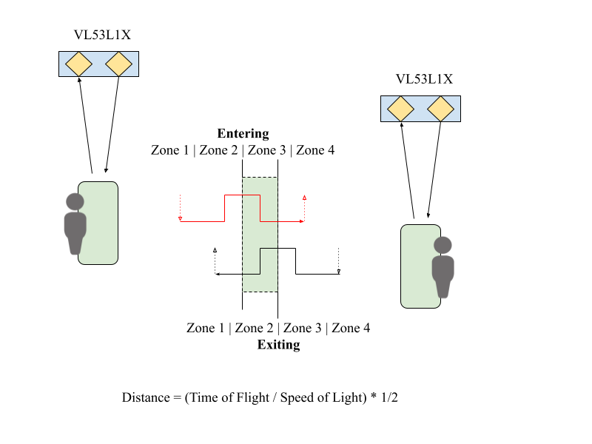
Figure 6: Representation of the Zone Timings and the Distance Equation

Appendix C Sensor Accumulation and Decision Making

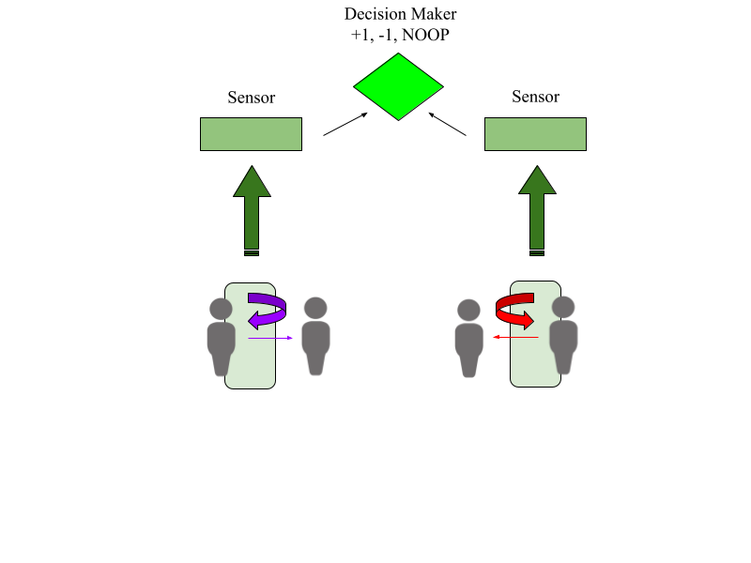
Figure 7: Representation of the Decision Making Process for Room Count

Appendix D Picture of Occupancy Counter Device and Casing

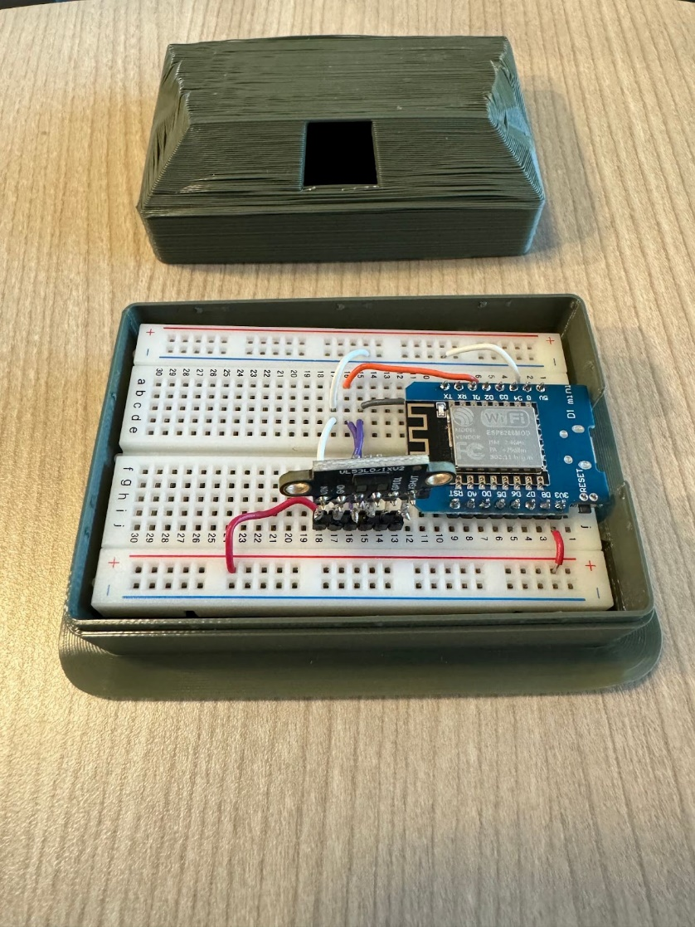

Figure 8: Outer Enclosure and Internal Connections of the Occupancy Counter

